EXTRA LAB PRACTICE FOR DATABASE CONCEPTS

1. Introduction to SQL

LAB EXERCISES:

Lab 3: Create a database called library_db and a table books with columns: book_id, title, author, publisher, year_of_publication, and price. Insert five records into the table.

Ans.

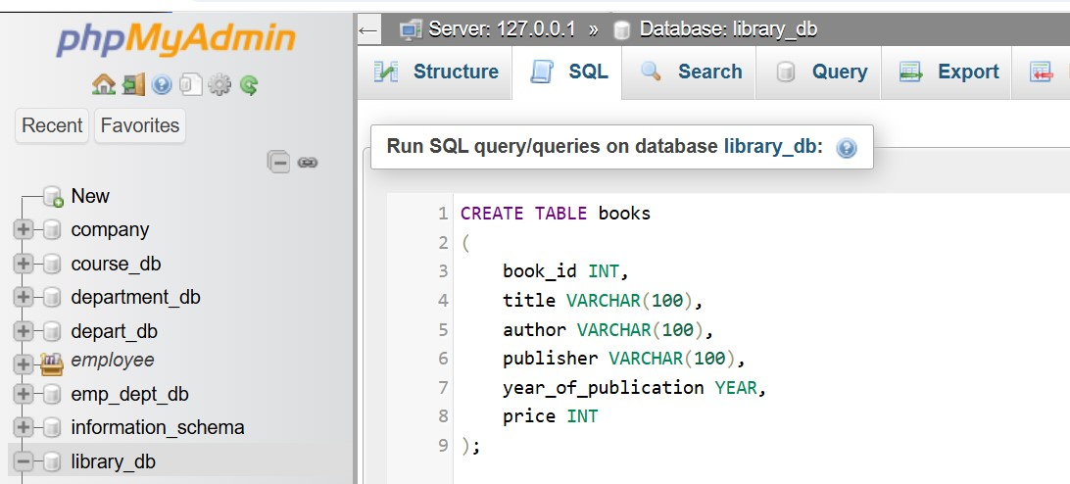

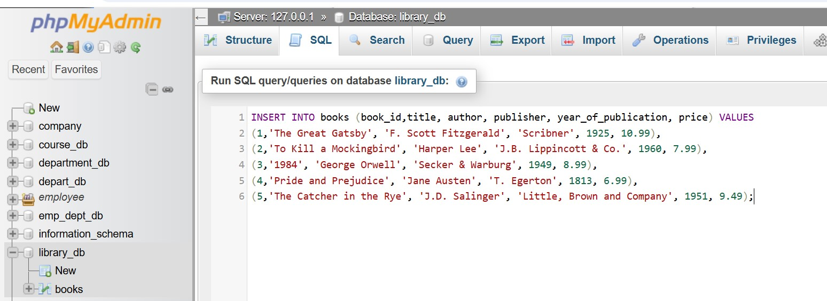

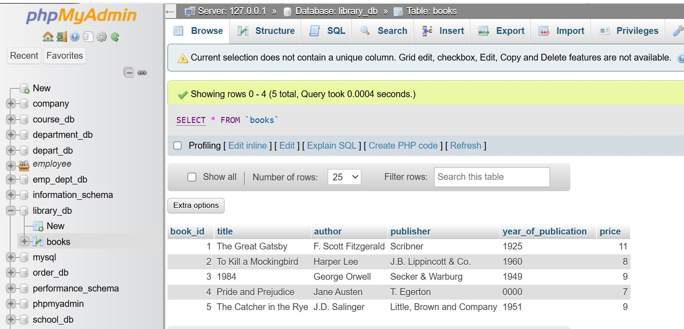

Lab 4: Create a table members in library_db with columns: member_id, member_name, date_of_membership, and email. Insert five records into this table.

Ans.

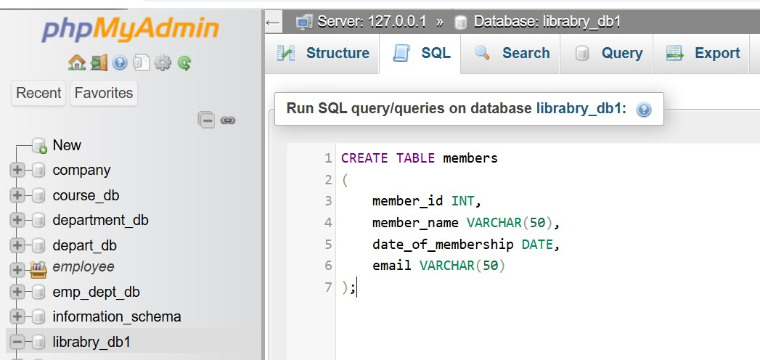

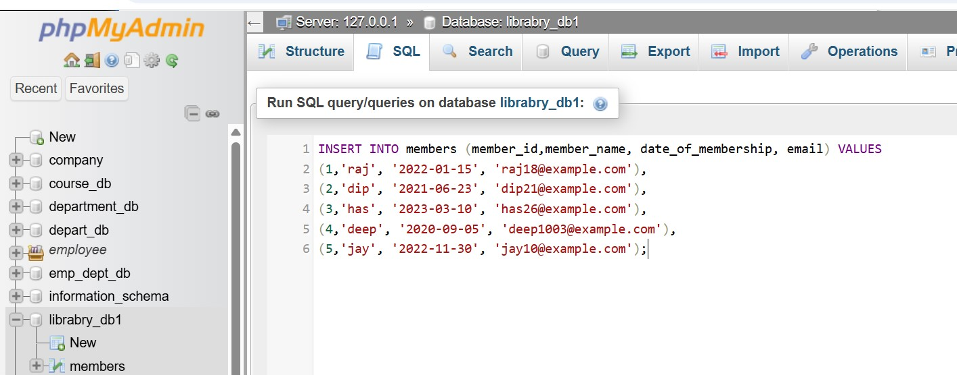

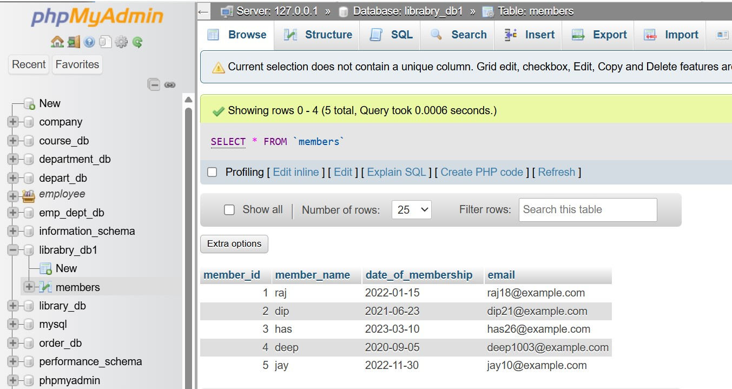

2. SQL Syntax

LAB EXERCISES:

Lab 3: Retrieve all members who joined the library before 2022. Use appropriate SQL syntax with WHERE and ORDER BY.

Ans.

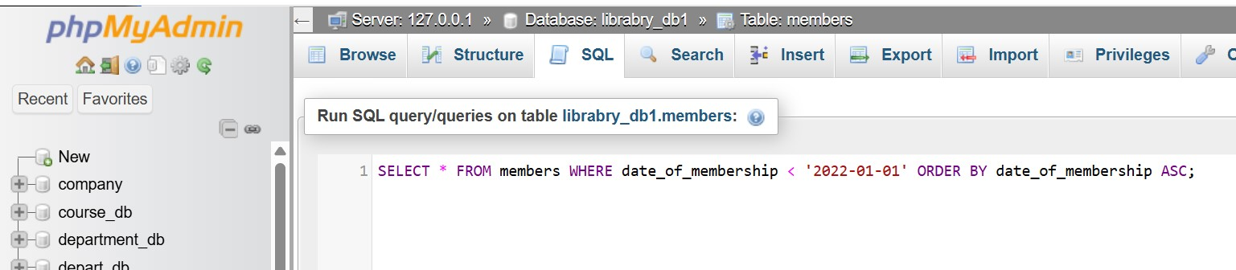

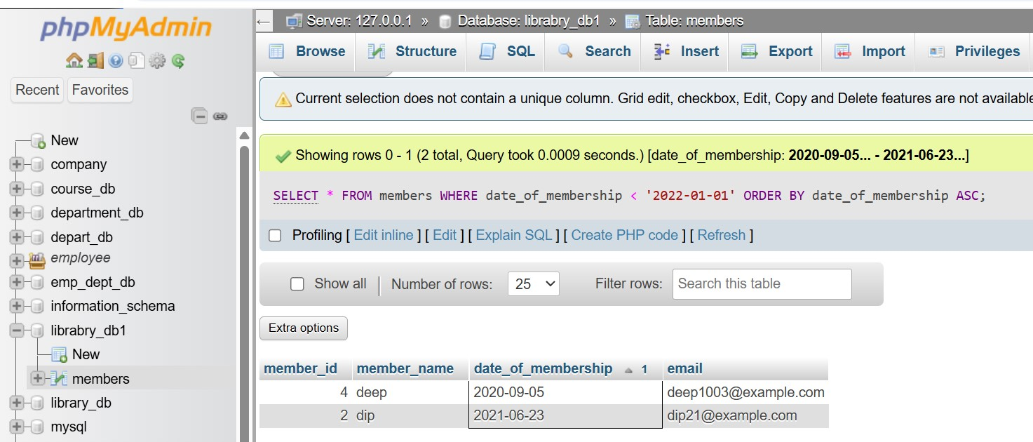

Lab 4: Write SQL queries to display the titles of books published by a specific author. Sort the results by year_of_publication in descending order.

Ans.

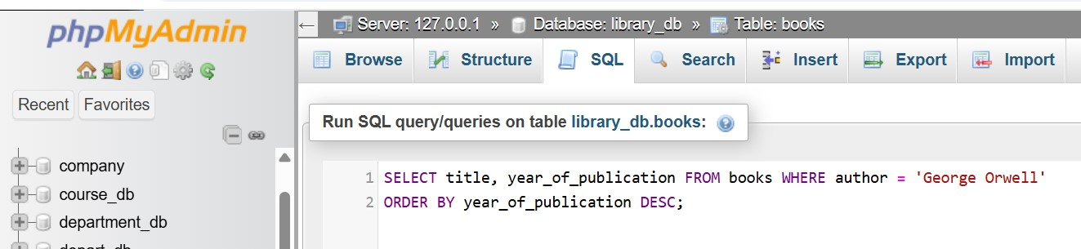

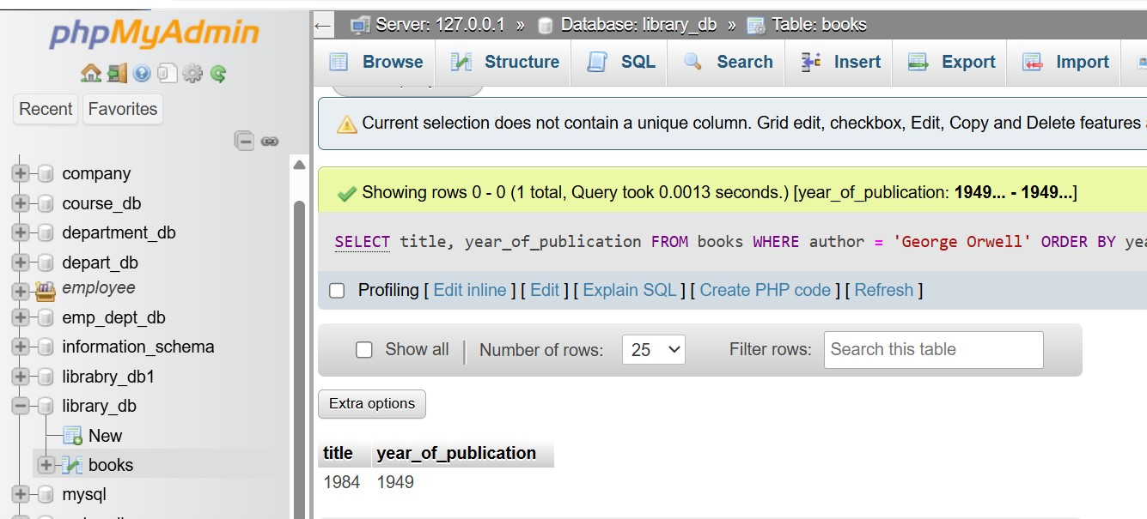

3. SQL Constraints

LAB EXERCISES:

Lab 3: Add a CHECK constraint to ensure that the price of books in the books table is greater than 0.

Ans.

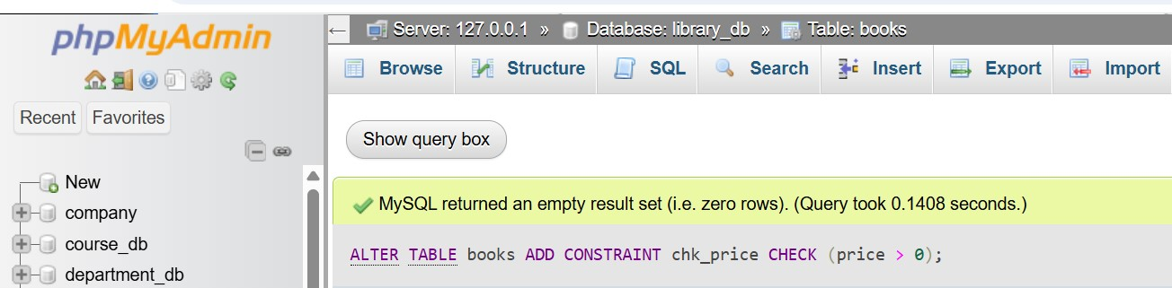

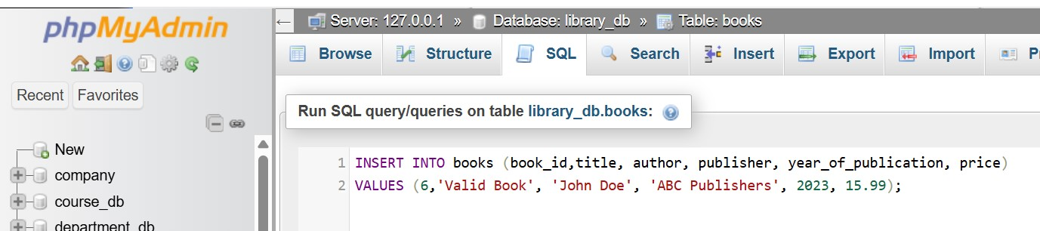

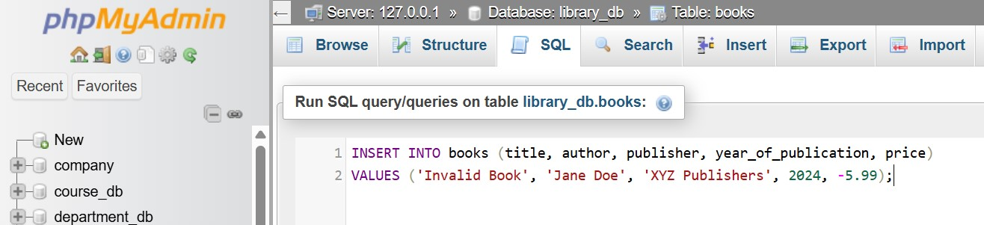

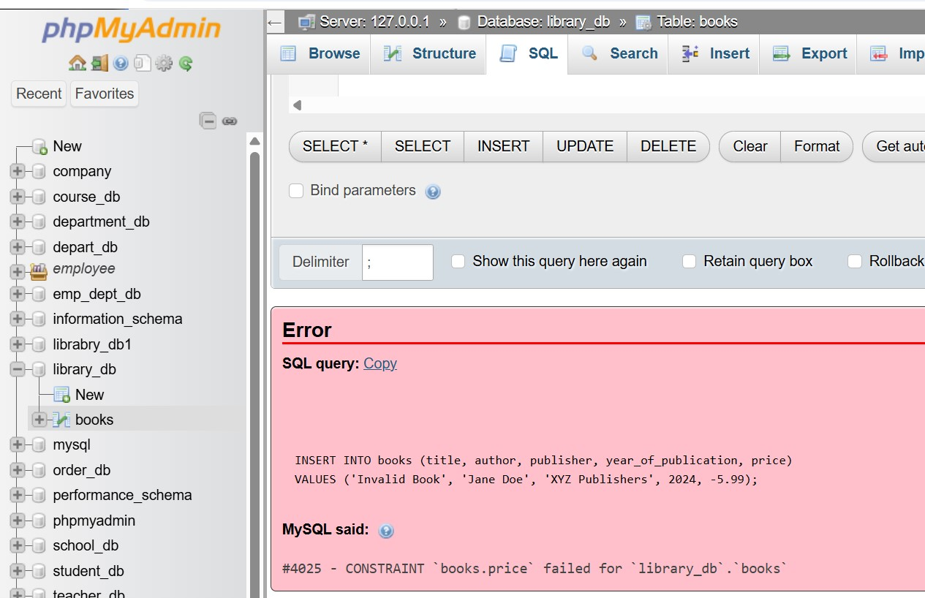

Lab 4: Modify the members table to add a UNIQUE constraint on the email column, ensuring that each member has a unique email address.

Ans.

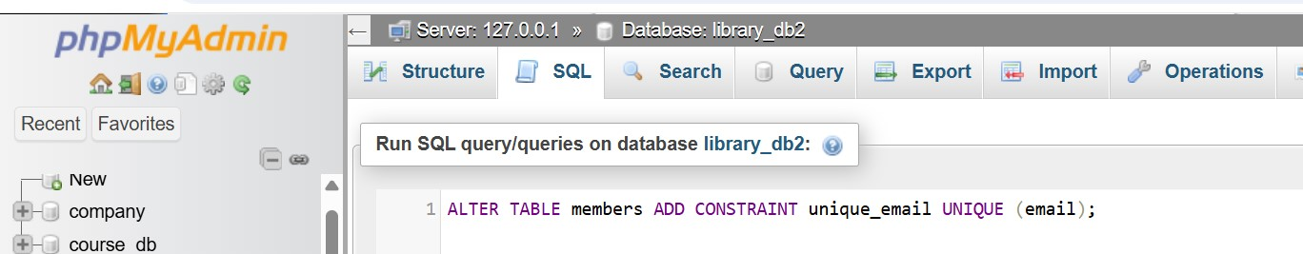

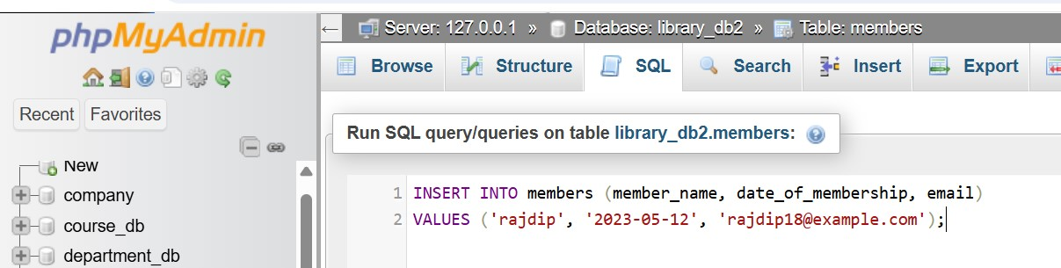

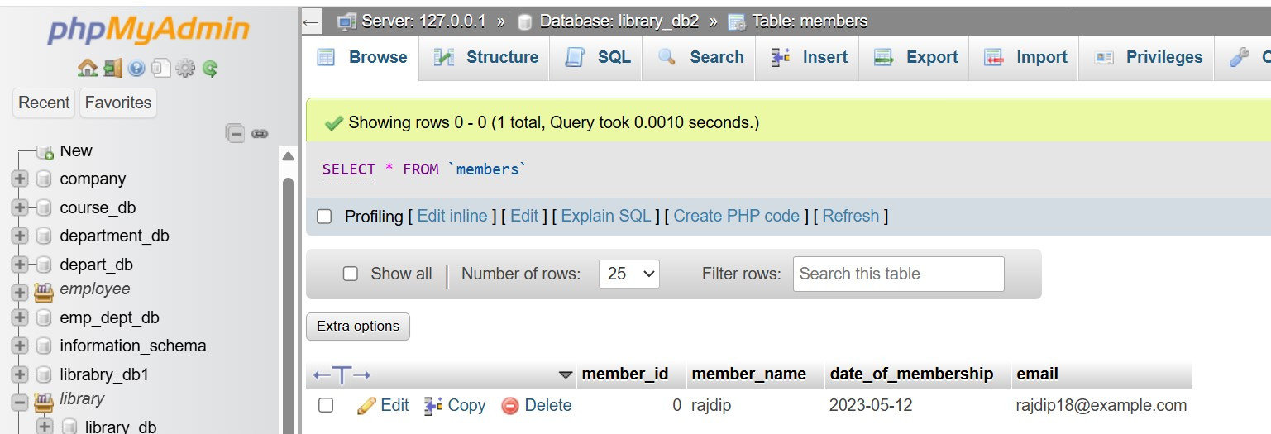

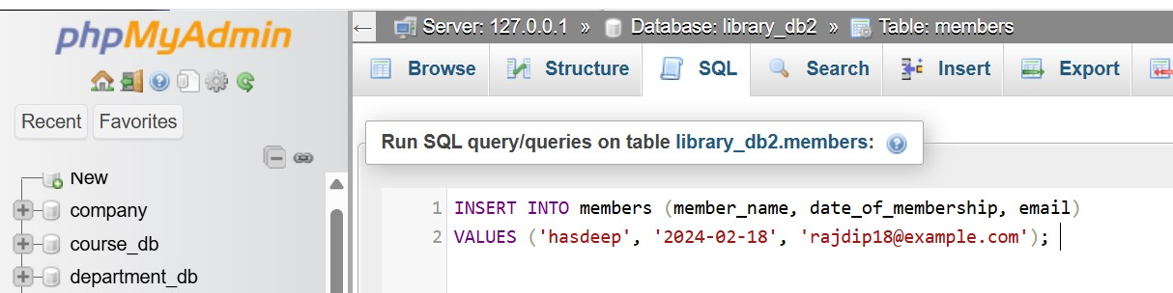

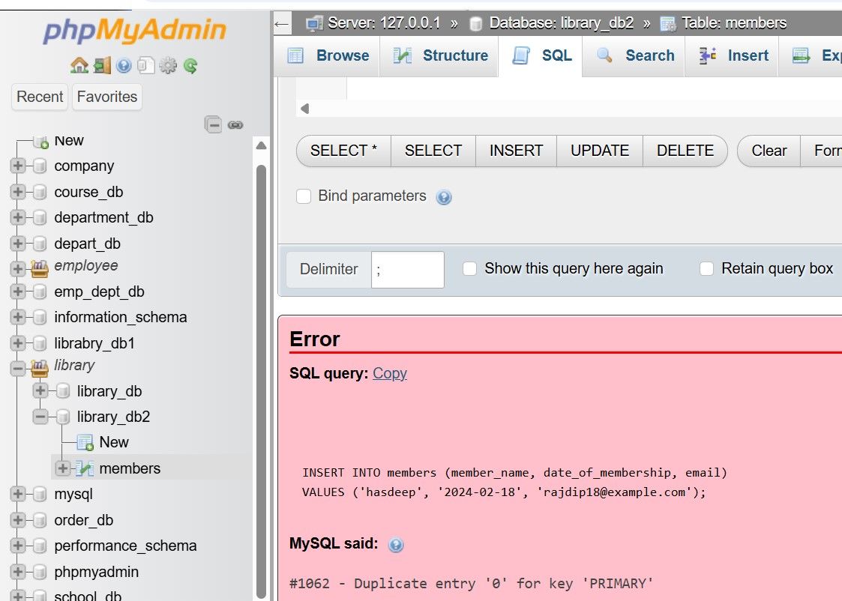

4. Main SQL Commands and Sub-commands(DDL)

LAB EXERCISES:

Lab 3: Create a table authors with the following columns: author_id, first_name, last_name, and country. Set author_id as the primary key.

Ans.

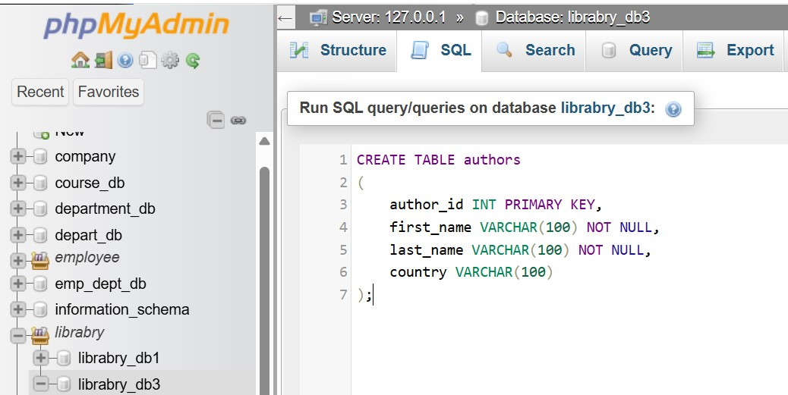

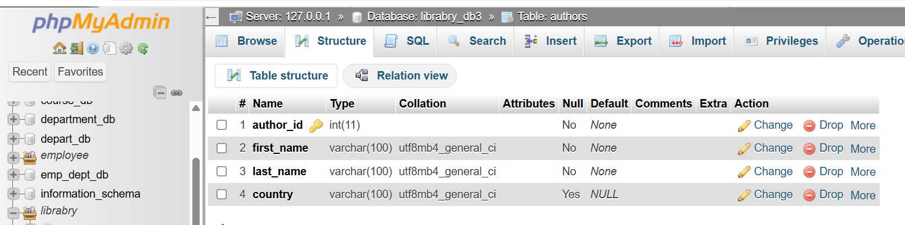

Lab 4: Create a table publishers with columns: publisher_id, publisher_name, contact_number, and address. Set publisher_id as the primary key and contact_number as unique.

Ans.

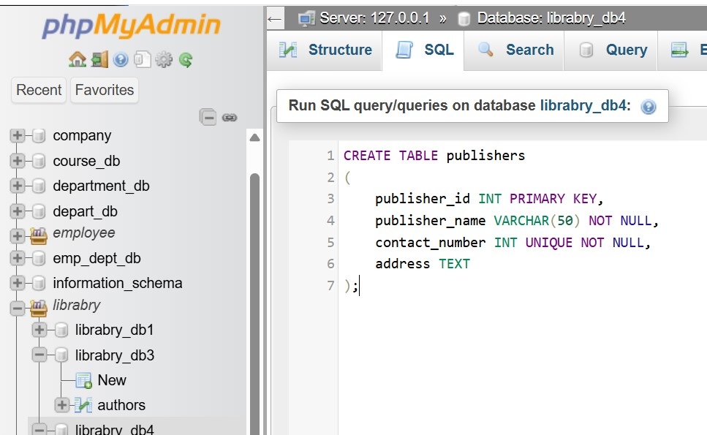

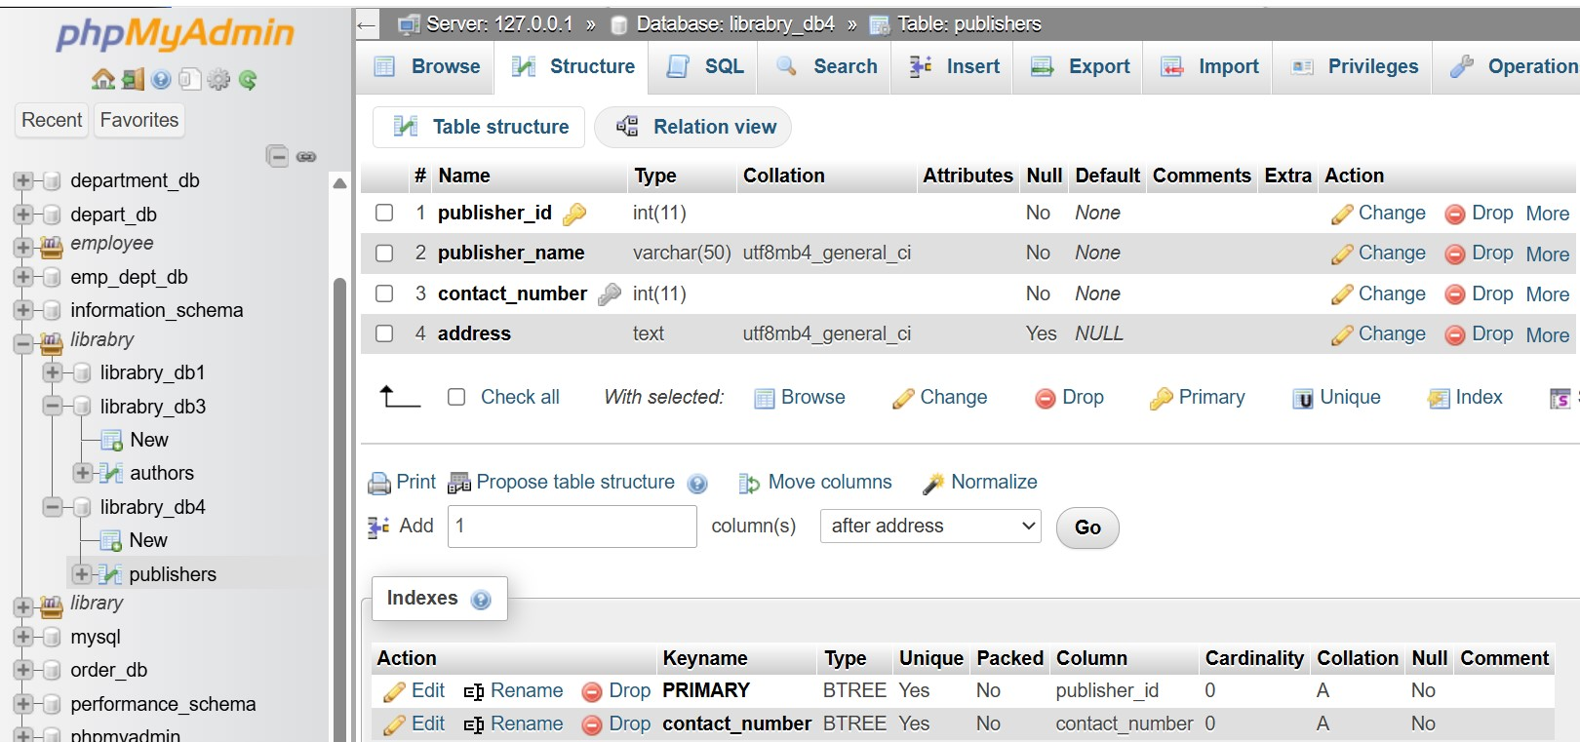

5. ALTER Command

LAB EXERCISES:

Lab 3: Add a new column genre to the books table. Update the genre for all existing records.

Ans.

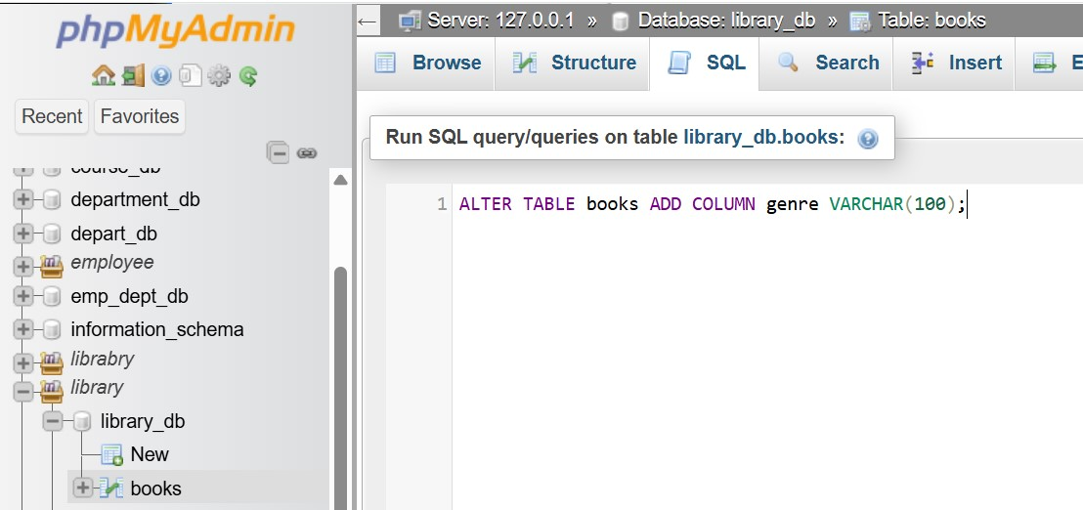

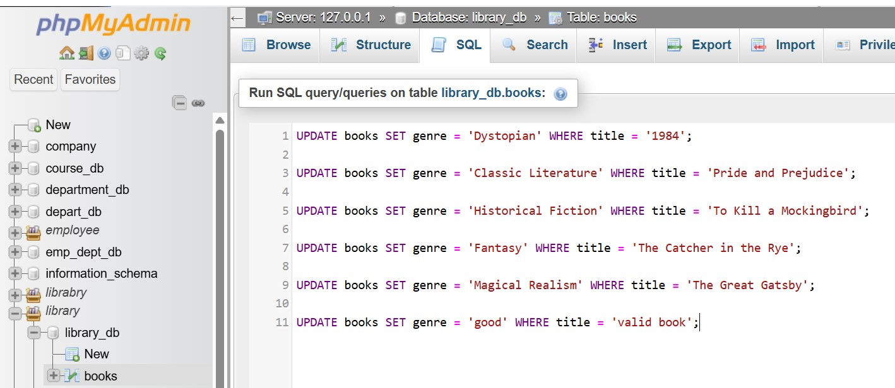

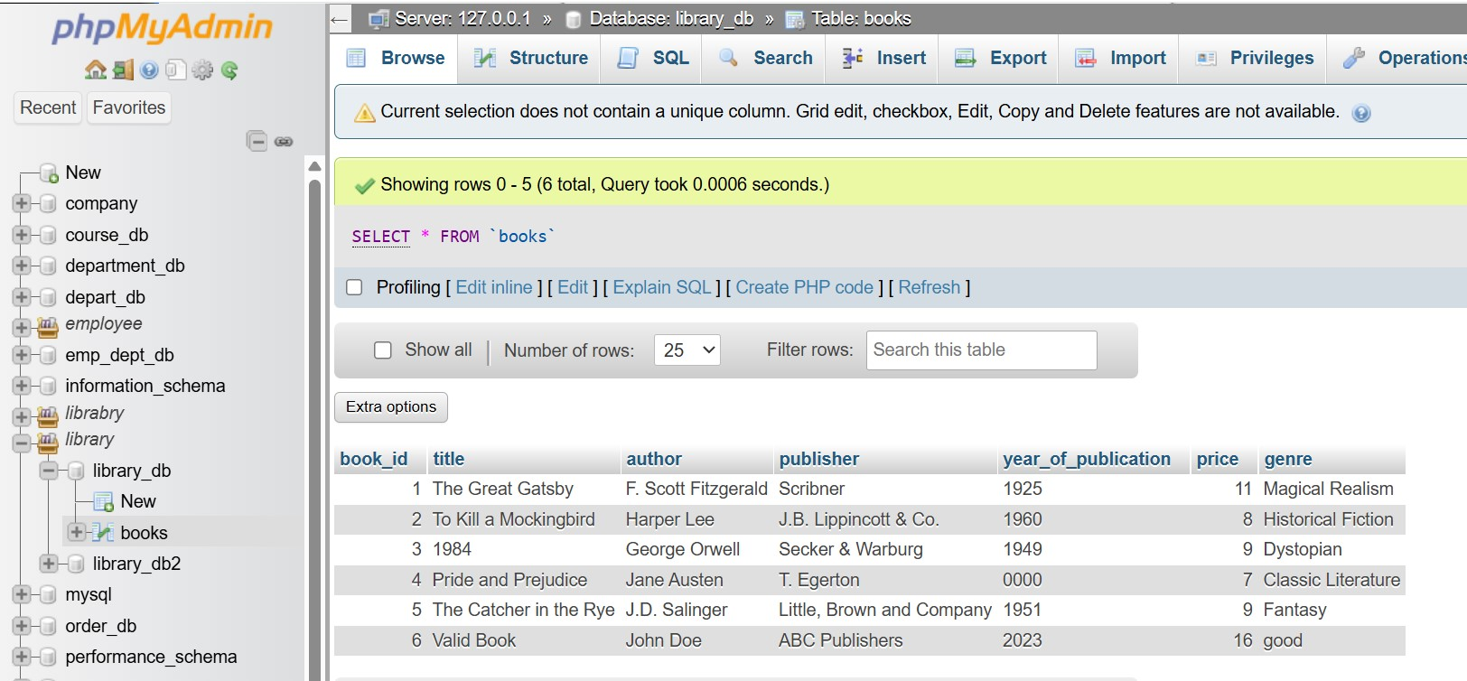

Lab 4: Modify the members table to increase the length of the email column to 100 characters.

Ans.

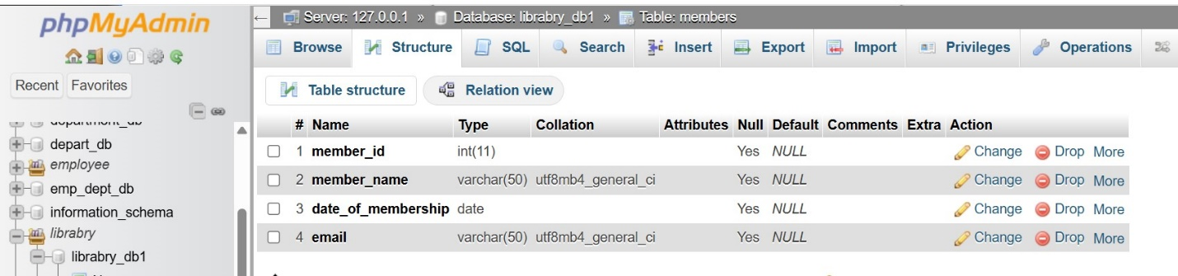

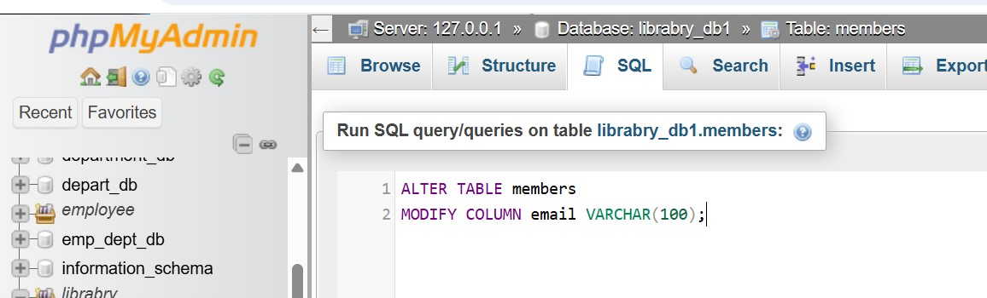

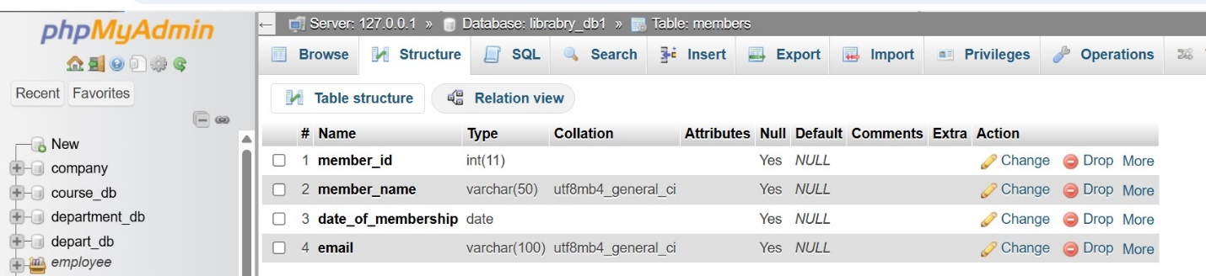

6. DROP Command

LAB EXERCISES:

Lab 3: Drop the publishers table from the database after verifying its structure.

Ans.

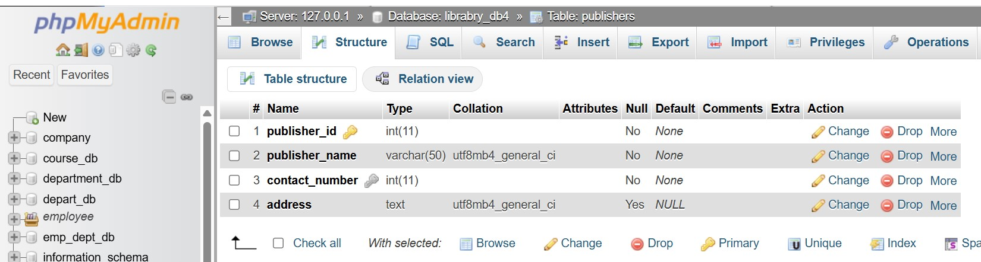

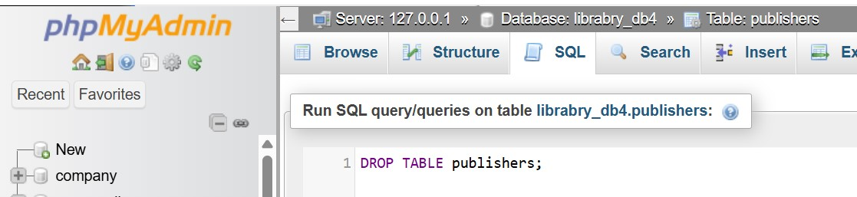

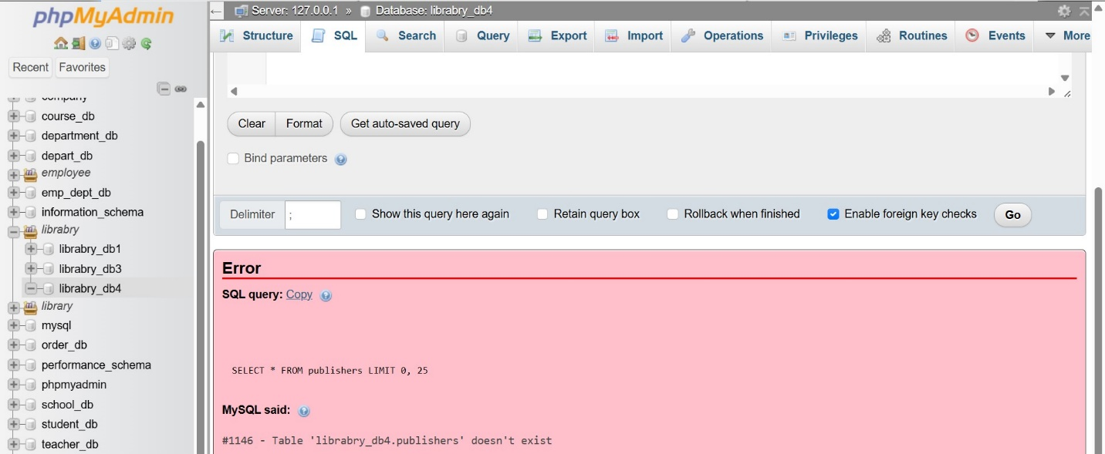

Lab 4: Create a backup of the member's table and then drop the original member's table.

Ans.

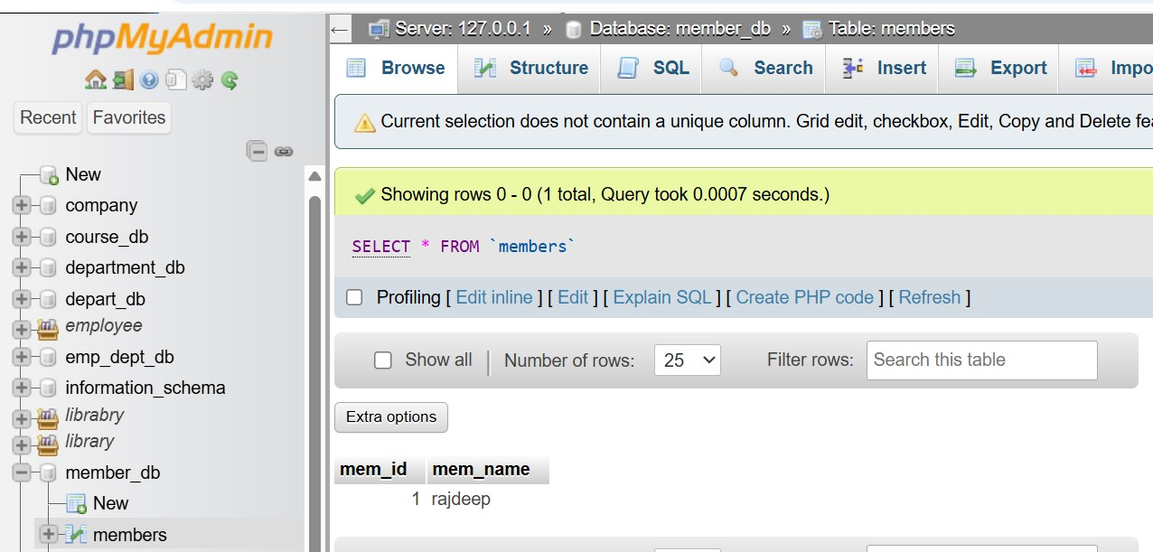

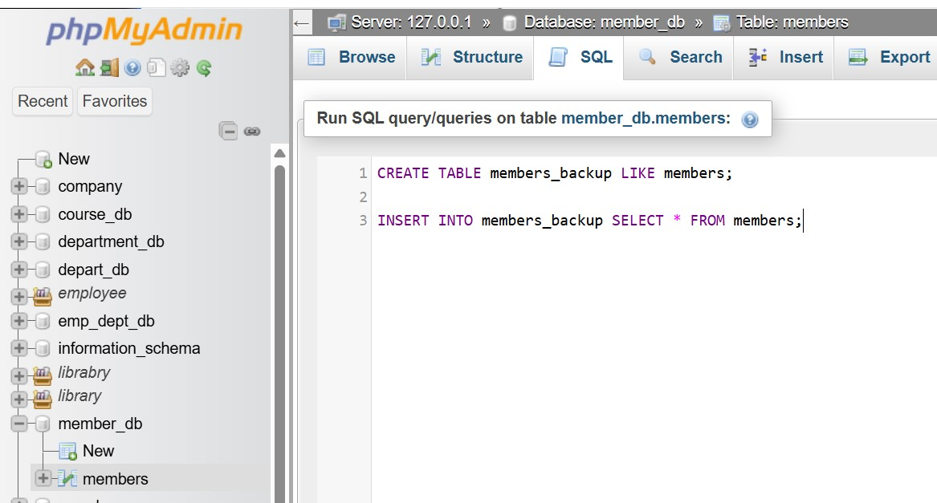

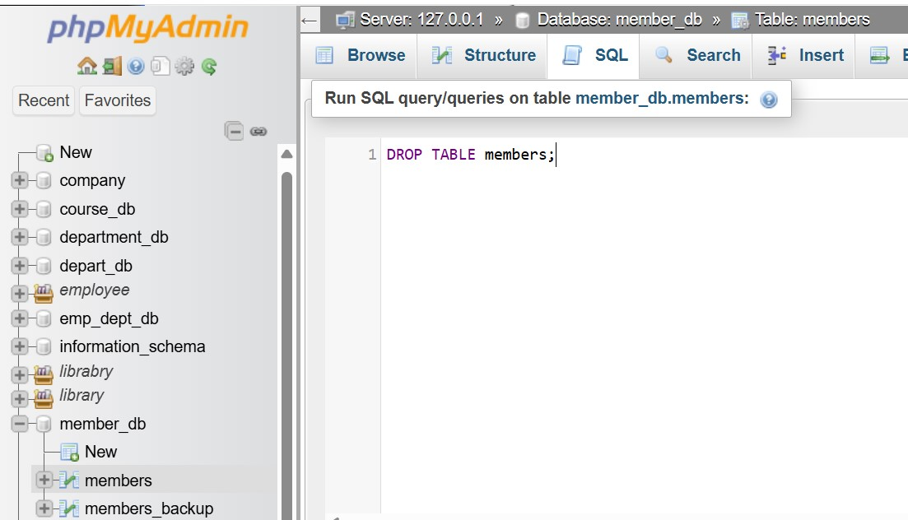

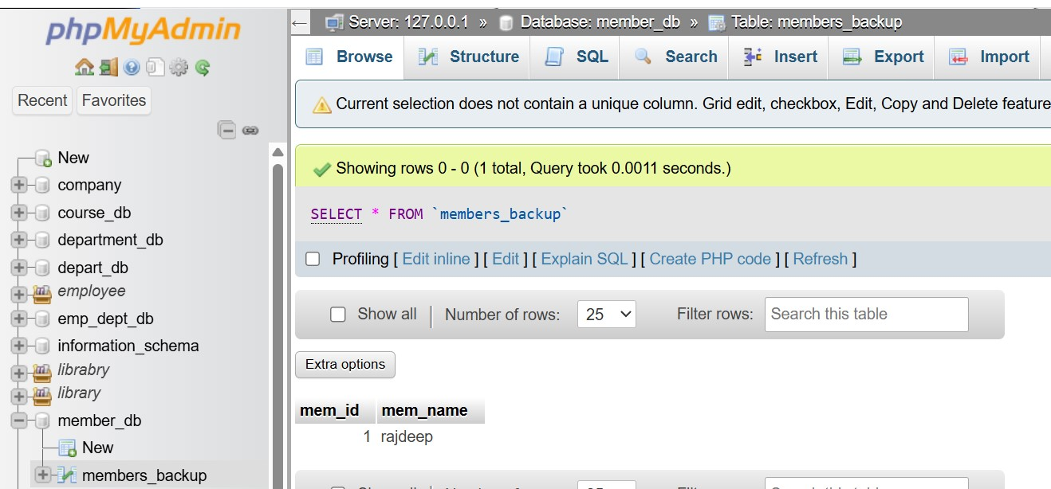

7. Data Manipulation Language (DML)

LAB EXERCISES:

Lab 4: Insert three new authors into the authors table, then update the last name of one of the authors.

Ans.

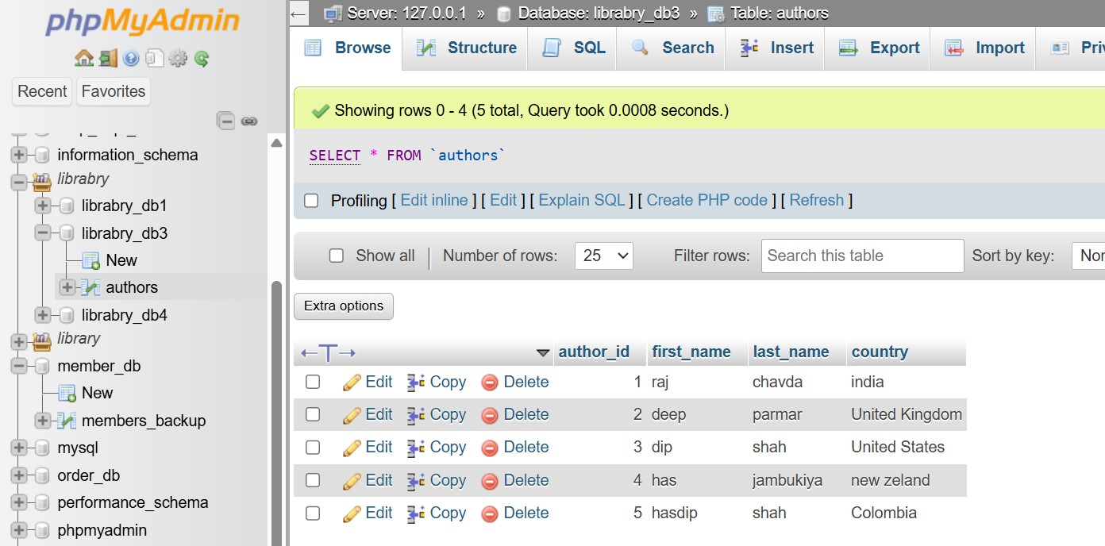

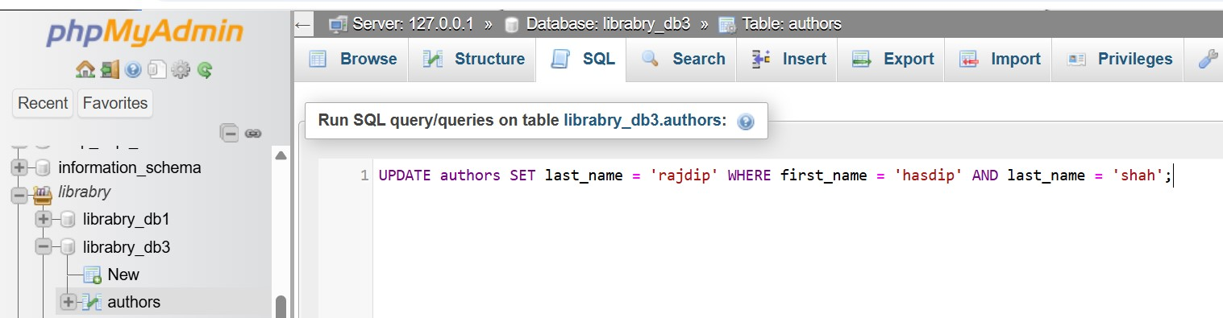

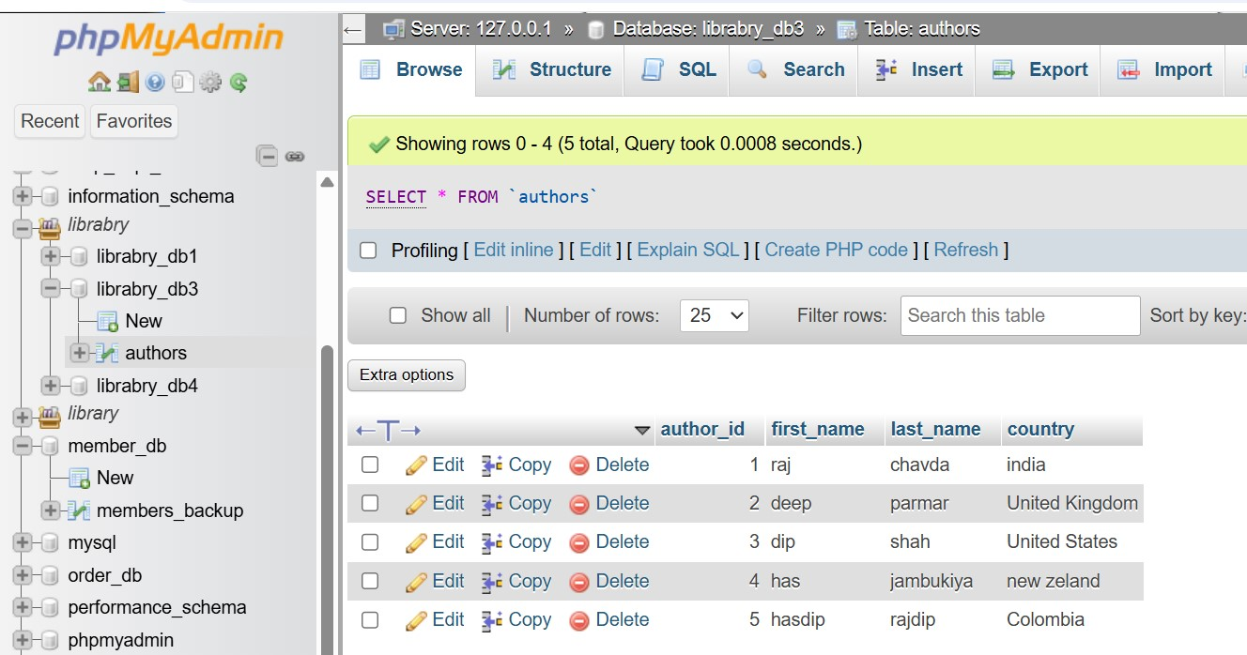

Lab 5: Delete a book from the books table where the price is higher than $100.

Ans.

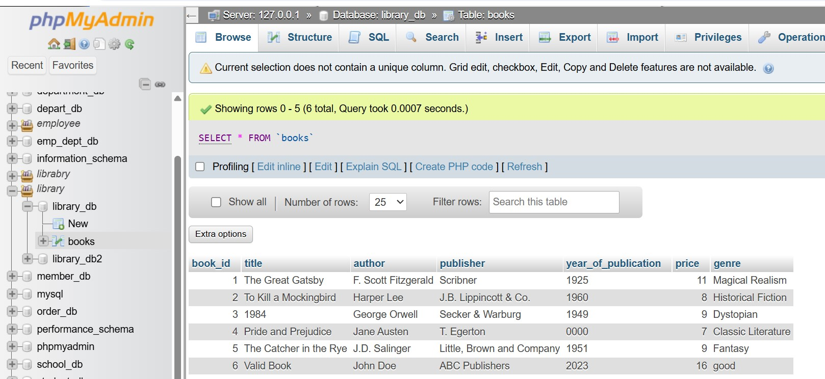

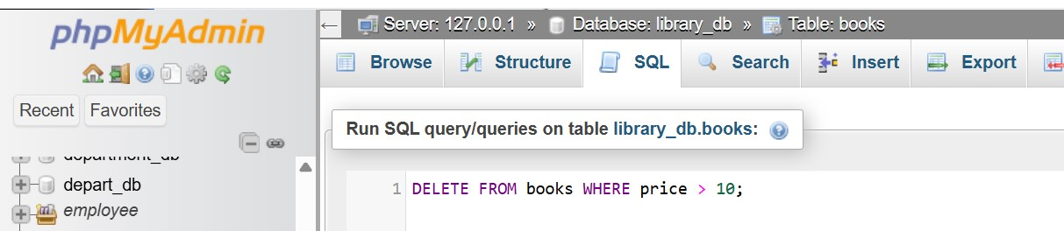

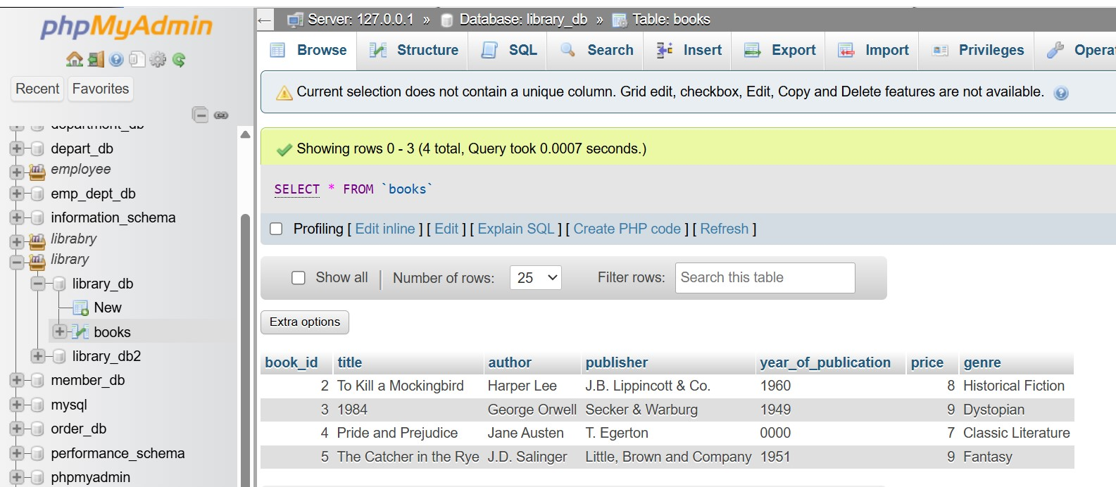

8. UPDATE Command

LAB EXERCISES:

Lab 3: Update the year_of_publication of a book with a specific book_id.

Ans.

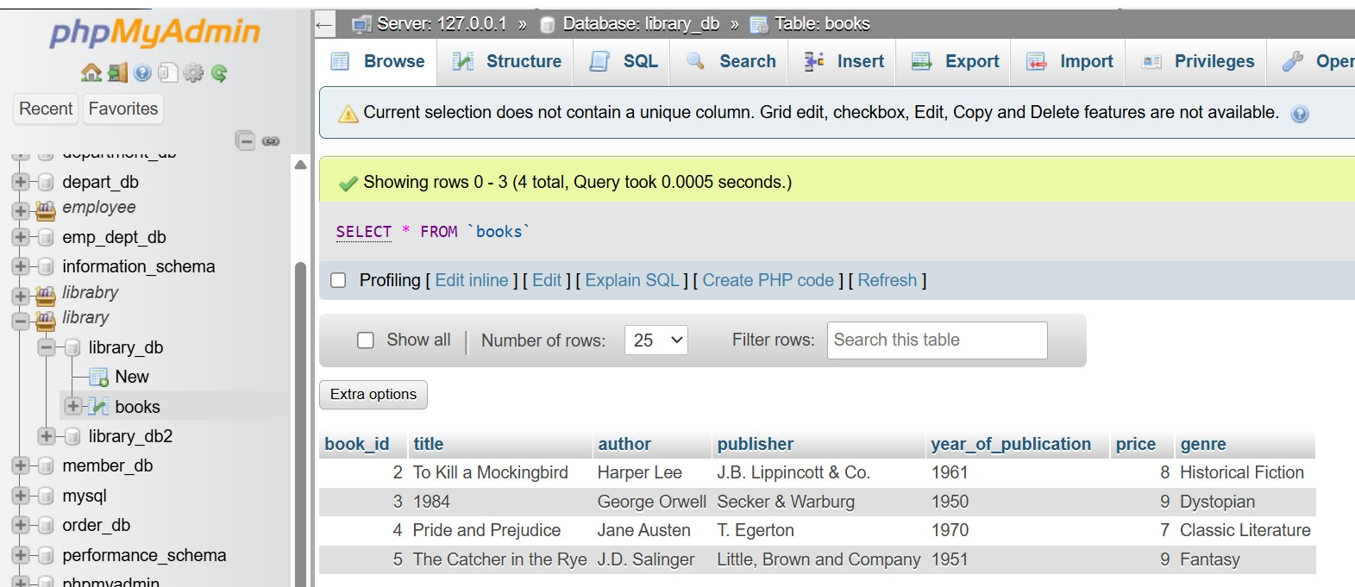

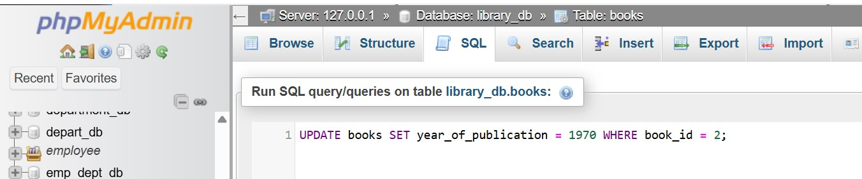

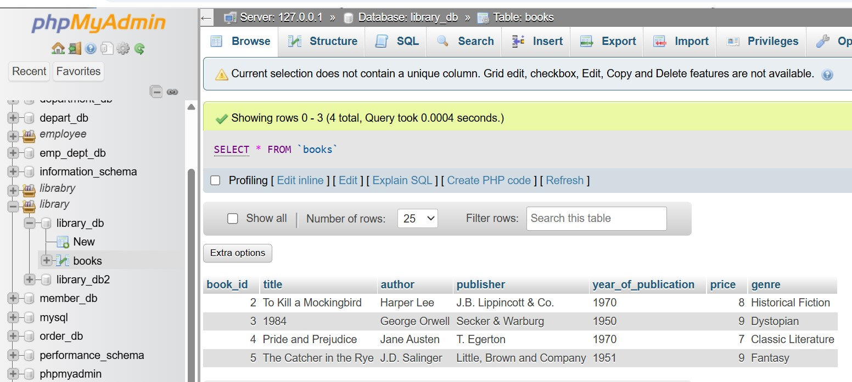

Lab 4: Increase the price of all books published before 2015 by 20%.

Ans.

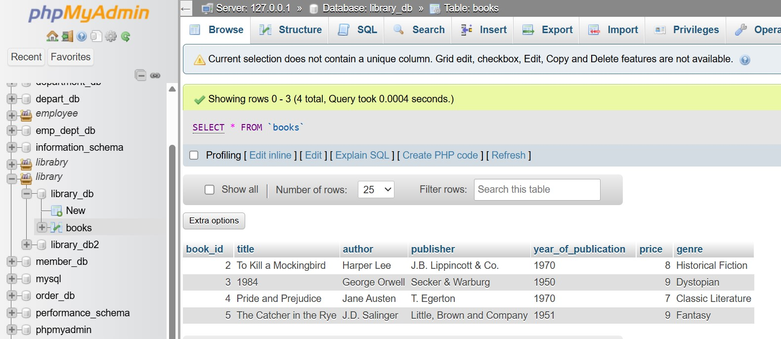

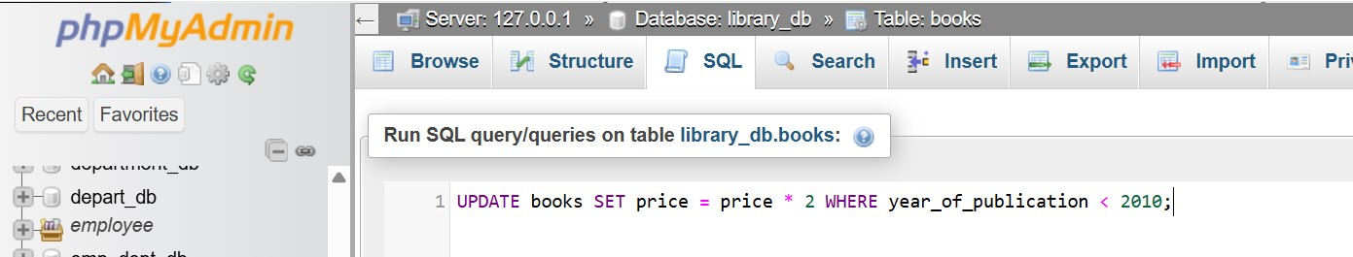

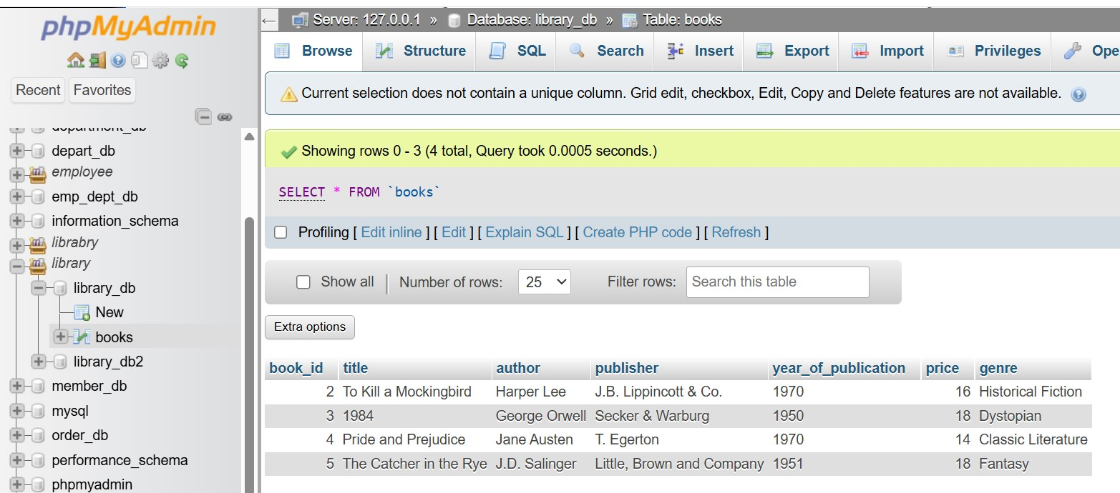

9. DELETE Command

LAB EXERCISES:

Lab 3: Remove all members who joined before 2021 from the members table.

Ans.

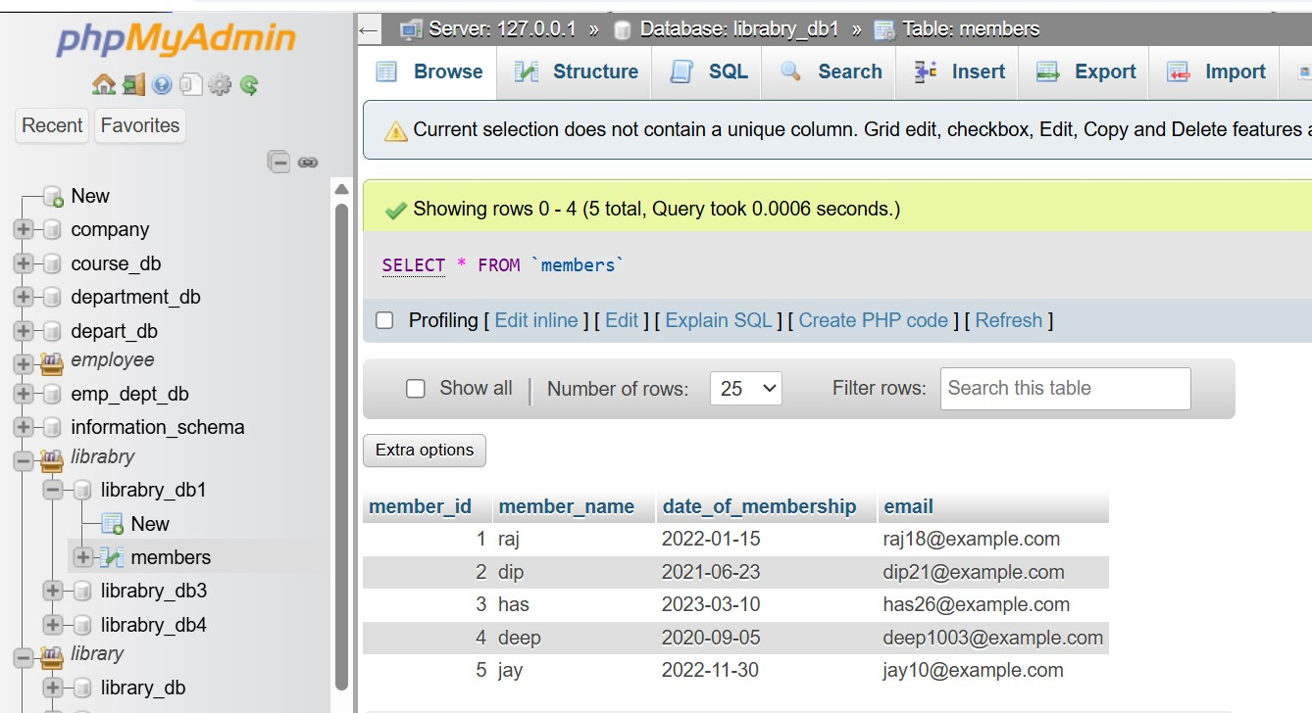

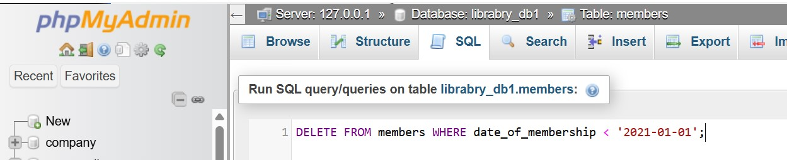

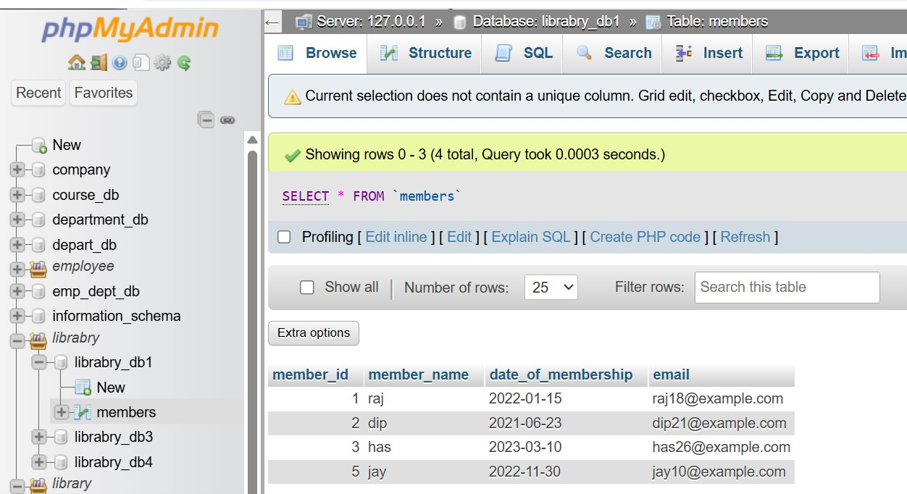

Lab 4: Delete all books that have a NULL value in the author column.

Ans.

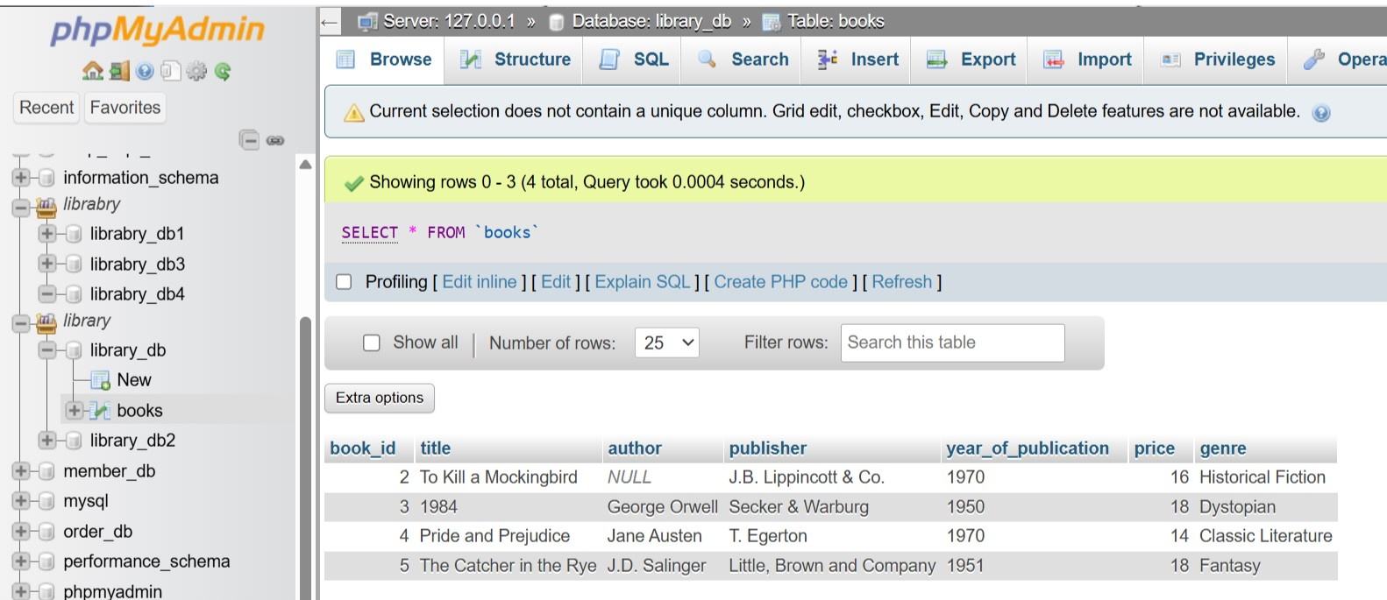

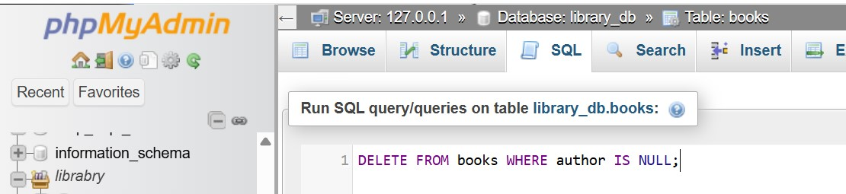

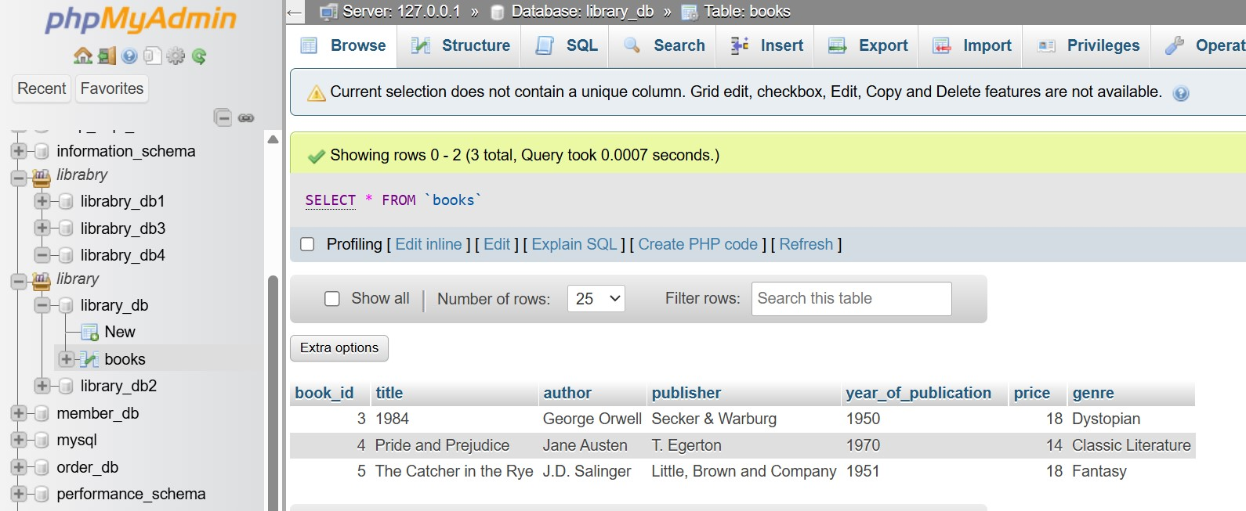

10. DataQuery Language (DQL)

LAB EXERCISES:

Lab 4: Write a query to retrieve all books with a price between $50 and $100.

Ans.

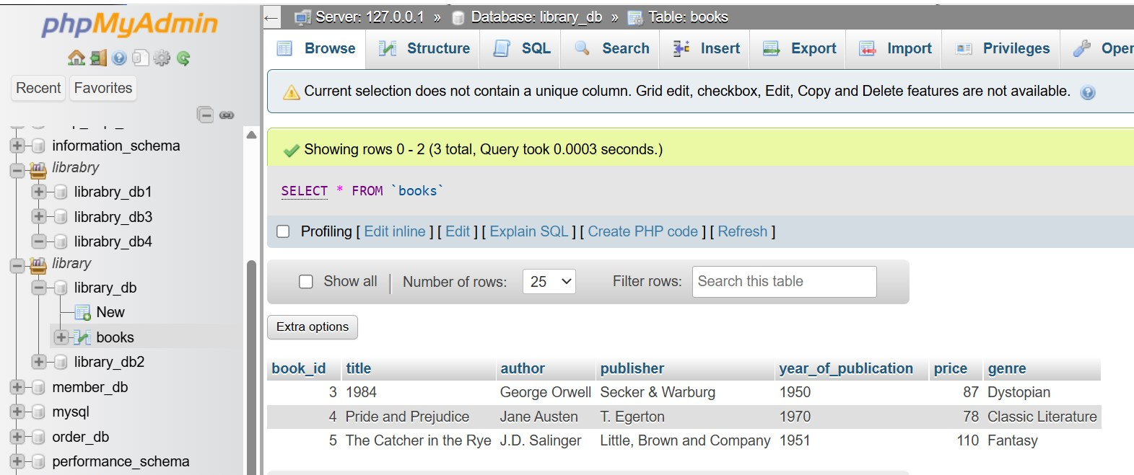

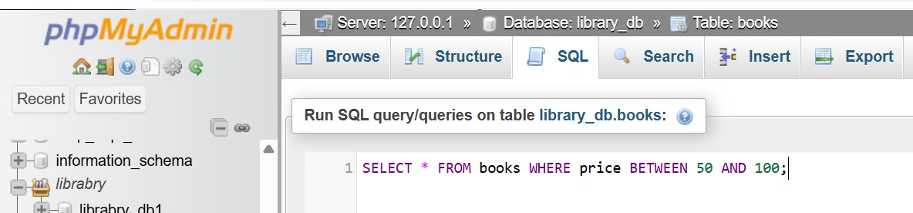

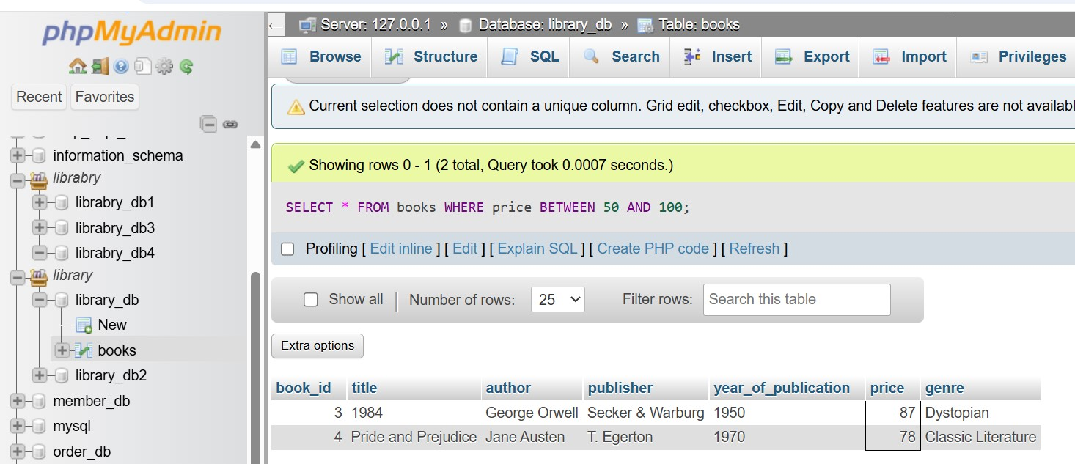

Lab 5: Retrieve the list of books sorted by author in ascending order and limit the results to the top 3 entries.

Ans.

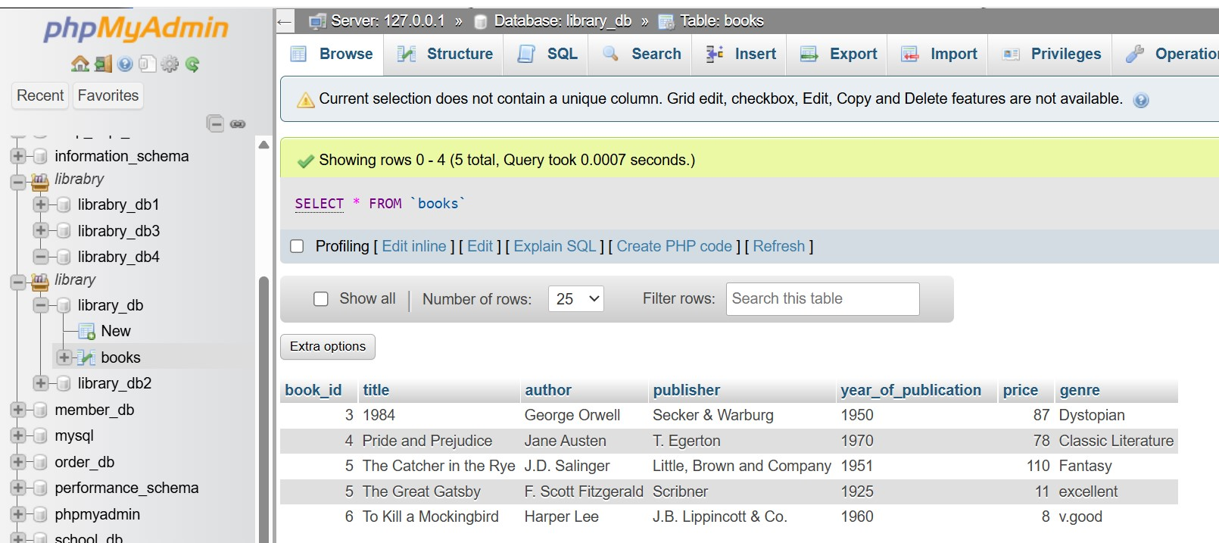

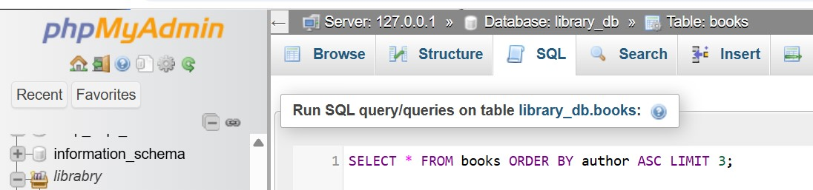

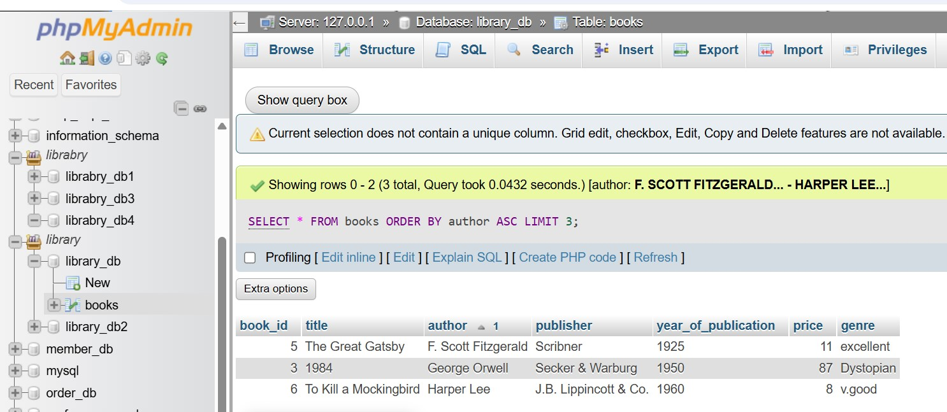

11. Data Control Language (DCL)

LAB EXERCISES:

Lab 3: Grant SELECT permission to a user named librarian on the books table.

Ans.

SELECT Permission:

GRANT SELECT ON library_db.books TO 'librarian'@'localhost';

Verify:

SHOW GRANTS FOR 'librarian'@'localhost';

Expected Output:

Grants for librarian@localhost

GRANT USAGE ON *.* TO `librarian`@`localhost`

GRANT SELECT ON `library_db`.`books` TO `librarian`@`localhost

Lab 4: Grant INSERT and UPDATE permissions to the user admin on the members table.

Ans.

Grant INSERT and UPDATE Permissions:

GRANT INSERT, UPDATE ON library_db.members TO 'admin'@'localhost';

Verify:

SHOW GRANTS FOR 'admin'@'localhost';

Expected Output:

Grants for admin@localhost

GRANT USAGE ON *.* TO `admin`@`localhost`

GRANT INSERT, UPDATE ON `library_db`.`members` TO `admin`@`localhost`

12. REVOKE Command

LAB EXERCISES:

Lab 3: Revoke the INSERT privilege from the user librarian on the books table.

Ans.

Revoke INSERT Privilege:

REVOKE INSERT ON library_db.books FROM 'librarian'@'localhost';

Verify:

SHOW GRANTS FOR 'librarian'@'localhost';

Expected Output :

Grants for librarian@localhost

GRANT USAGE ON *.* TO `librarian`@`localhost`

GRANT SELECT ON `library_db`.`books` TO `librarian`@`localhost`

Re-Grant INSERT :

GRANT INSERT ON library_db.books TO 'librarian'@'localhost';

Lab 4: Revoke all permissions from user admin on the members table.

Ans.

Revoke All Permissions:

REVOKE ALL PRIVILEGES ON library_db.members FROM 'admin'@'localhost';

Verify:

SHOW GRANTS FOR 'admin'@'localhost';

Expected Output:

Grants for admin@localhost

GRANT USAGE ON *.* TO `admin`@`localhost`

Drop the User:

DROP USER 'admin'@'localhost';

Re-Grant Permissions:

GRANT INSERT, UPDATE ON library_db.members TO 'admin'@'localhost';

13. Transaction Control Language (TCL)

LAB EXERCISES:

Lab 3: Use COMMIT after inserting multiple records into the books table, then make another insertion and perform a ROLLBACK.

Ans.

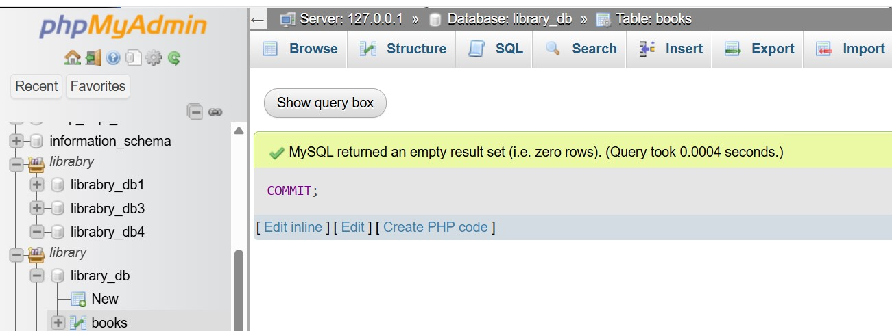

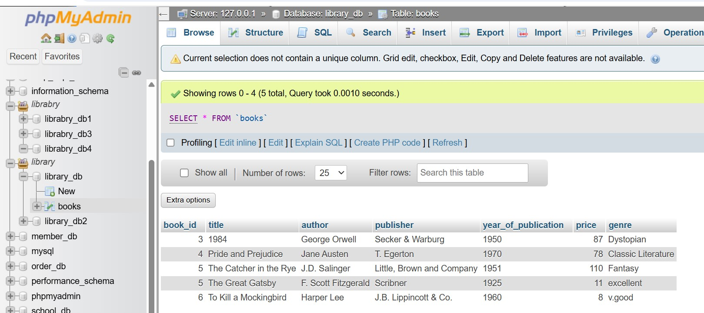

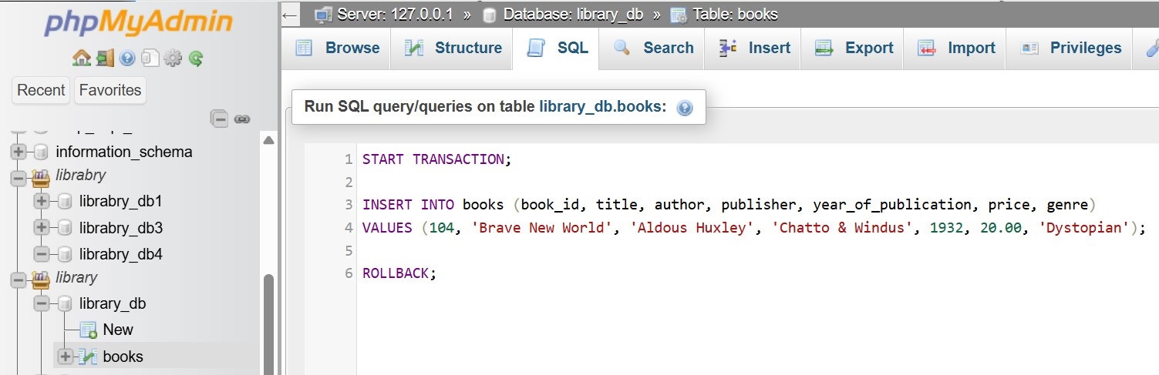

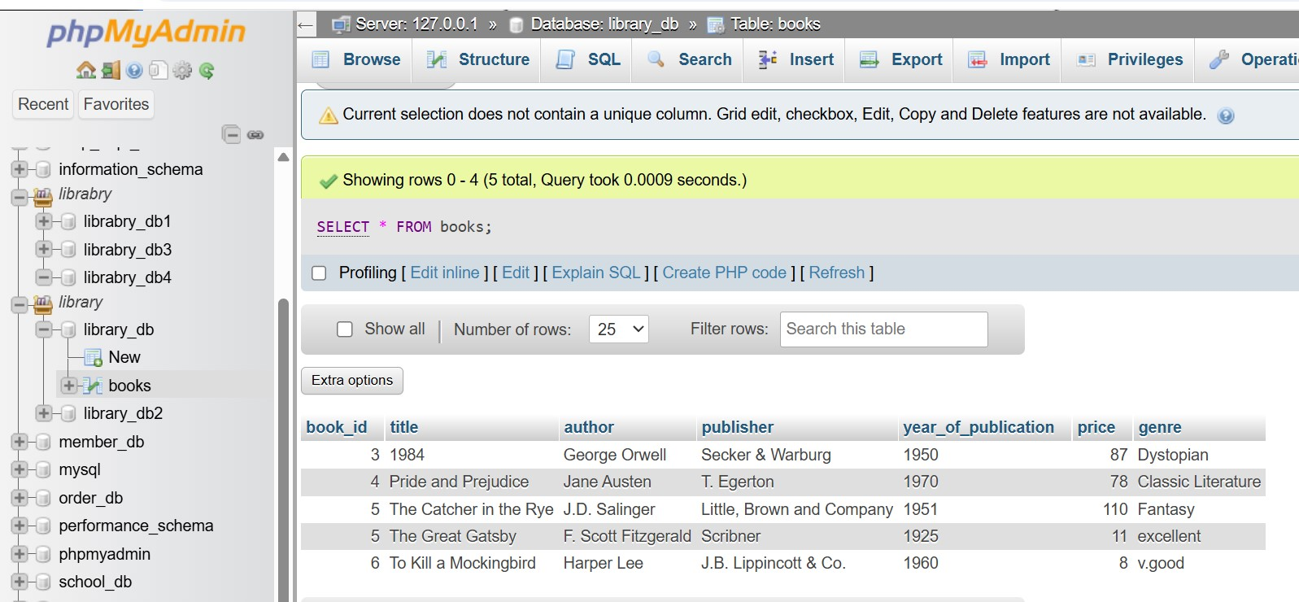

Lab 4: Set a SAVEPOINT before making updates to the members table, perform some updates, and then roll back to the SAVEPOINT.

Ans.

SAVEPOINT before_update;

UPDATE members

SET email = 'updated_email1@example.com'

WHERE member_id = 1;

UPDATE members

SET email = 'updated_email2@example.com'

WHERE member_id = 2;

SELECT * FROM members;

ROLLBACK TO SAVEPOINT before_update;

RELEASE SAVEPOINT before_update;

14. SQL Joins

LAB EXERCISES:

Lab 3: Perform an INNER JOIN between books and authors tables to display the title of books and their respective authors' names.

Ans.

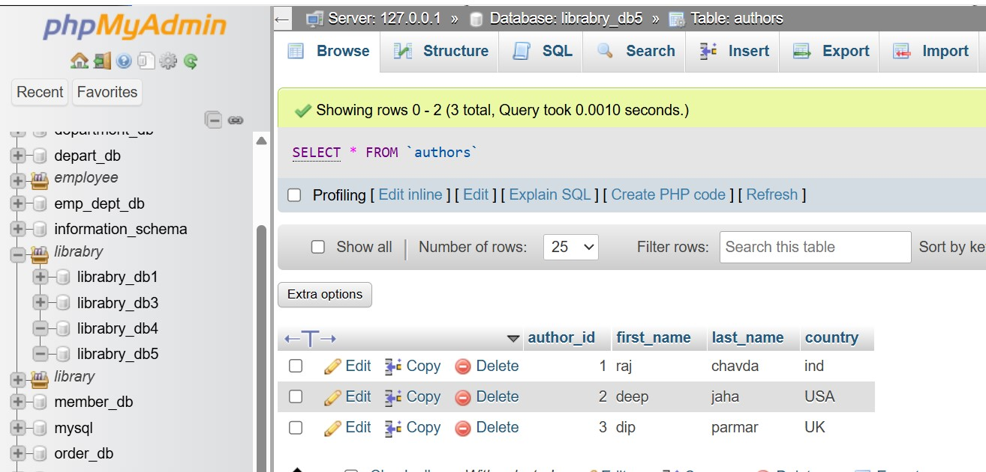

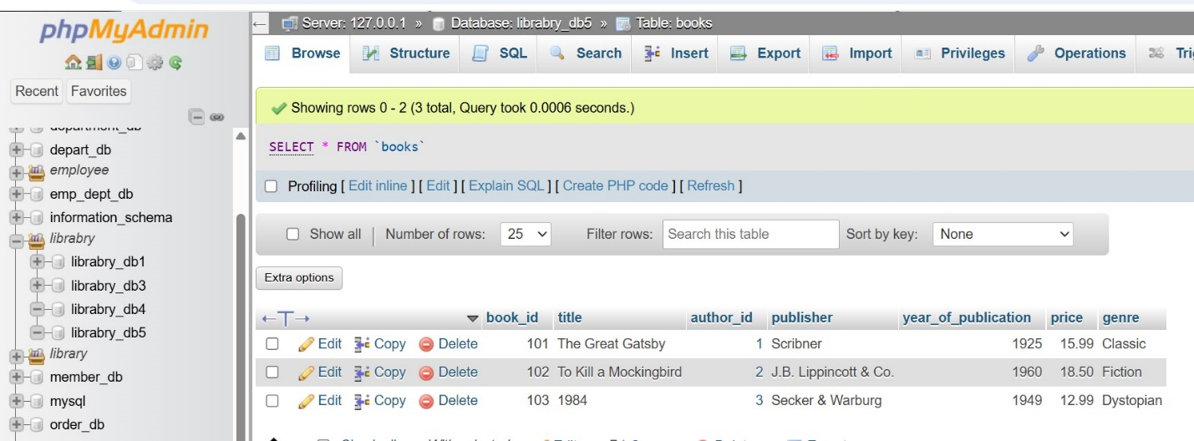

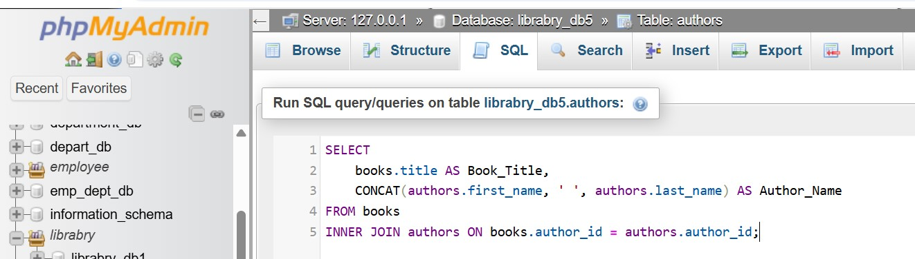

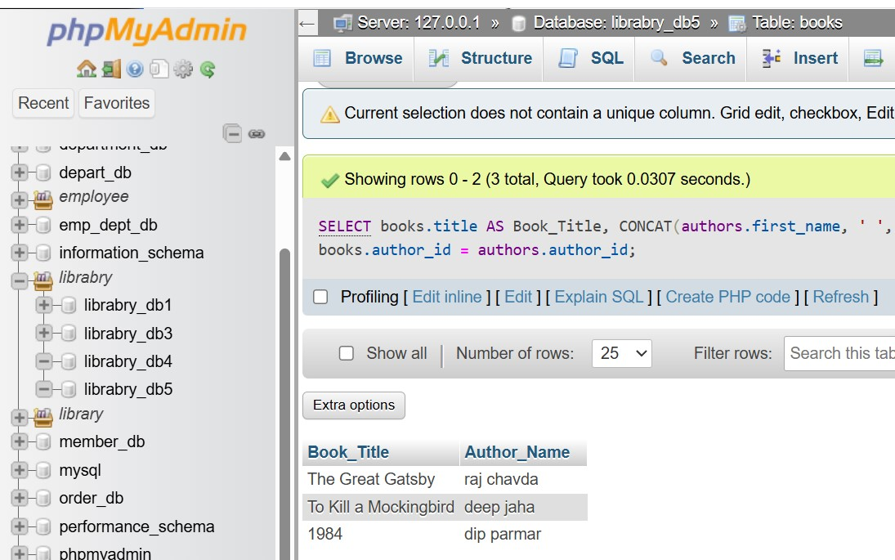

Lab 4: Use a FULL OUTER JOIN to retrieve all records from the books and authors tables, including those with no matching entries in the other table.

Ans.

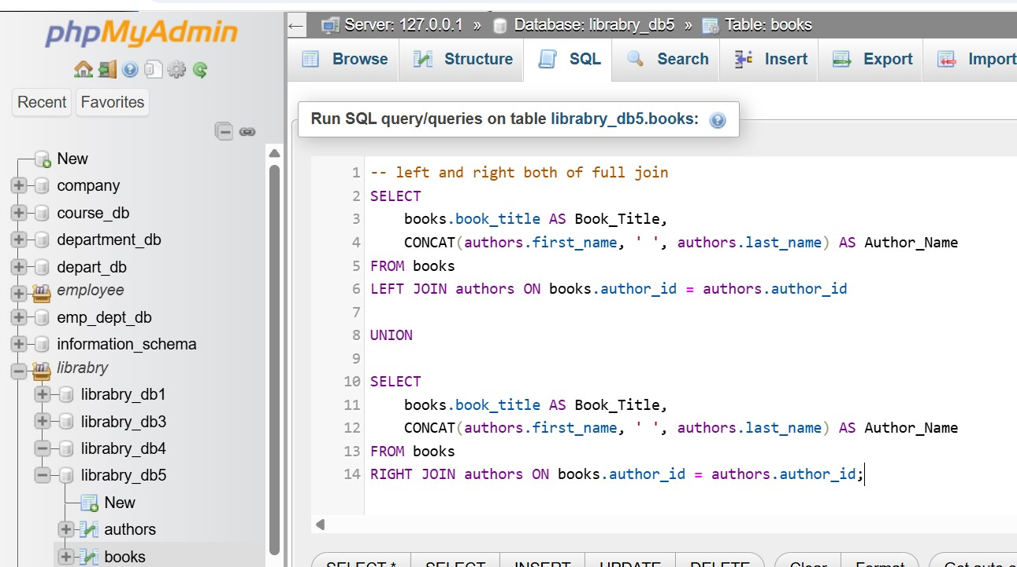

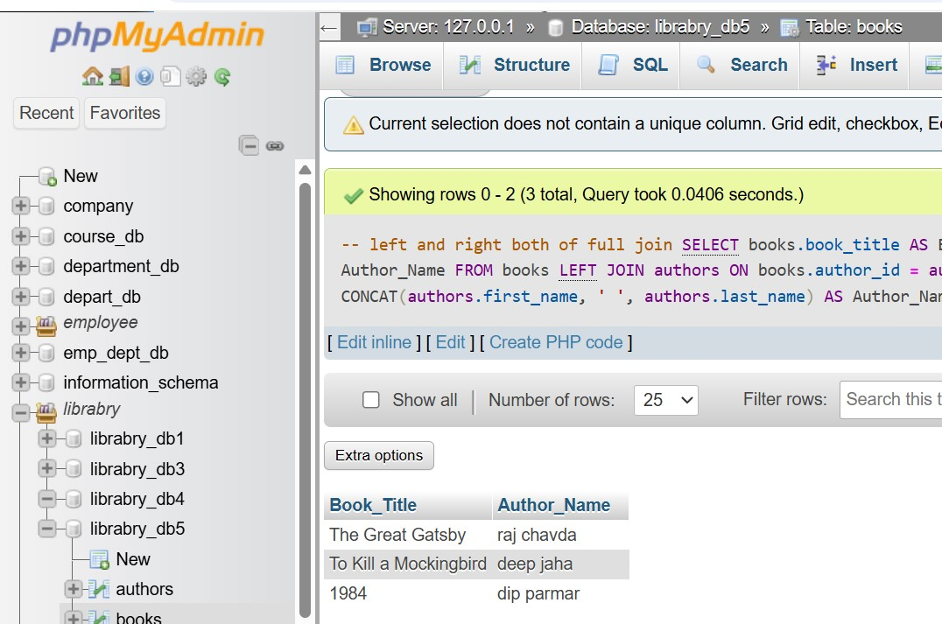

15. SQL Group By

LAB EXERCISES:

Lab 3: Group books by genre and display the total number of books in each genre.

Ans.

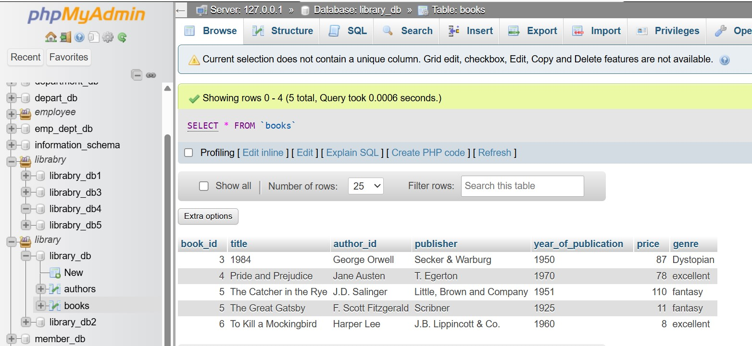

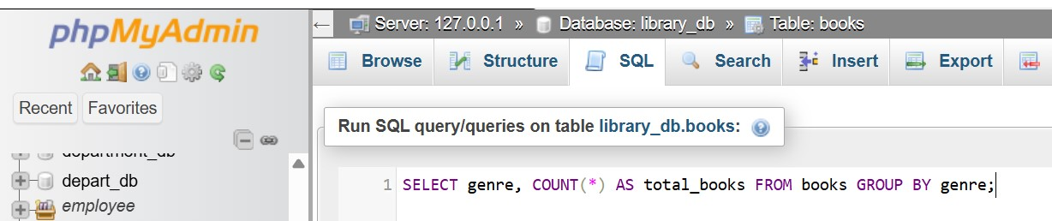

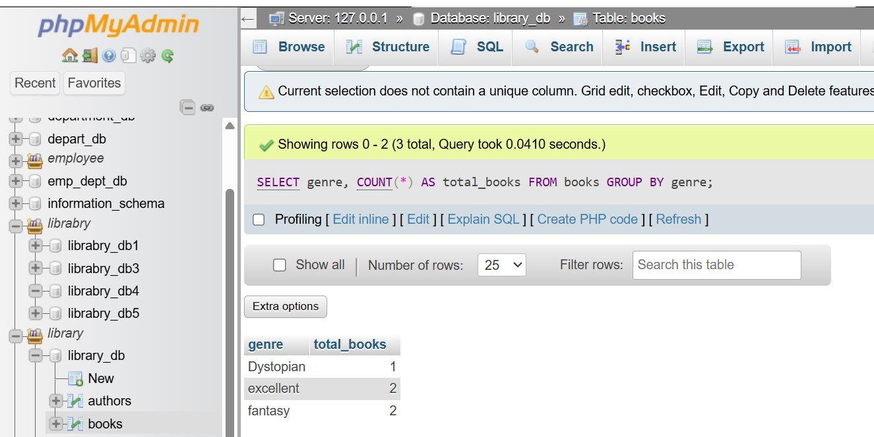

Lab 4: Group members by the year they joined and find the number of members who joined each year.

Ans.

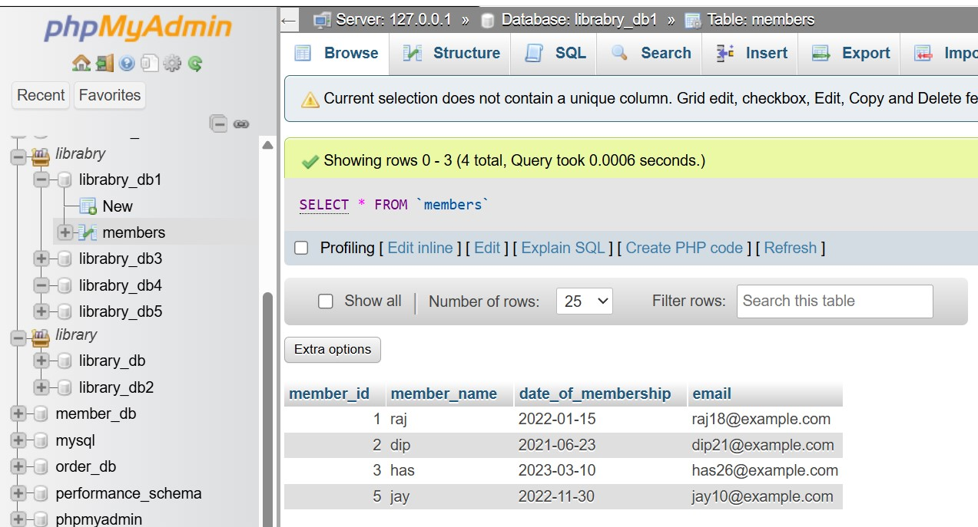

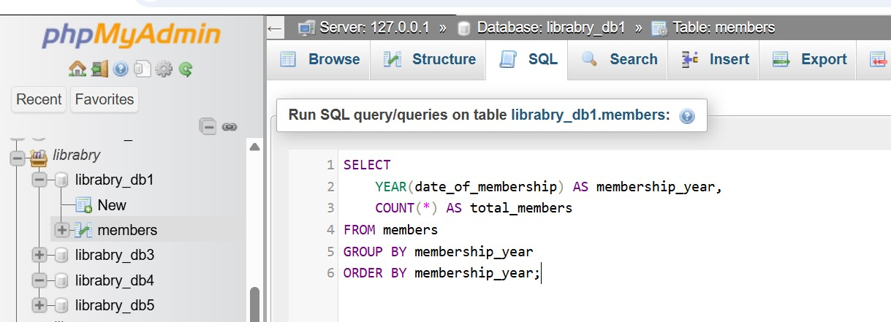

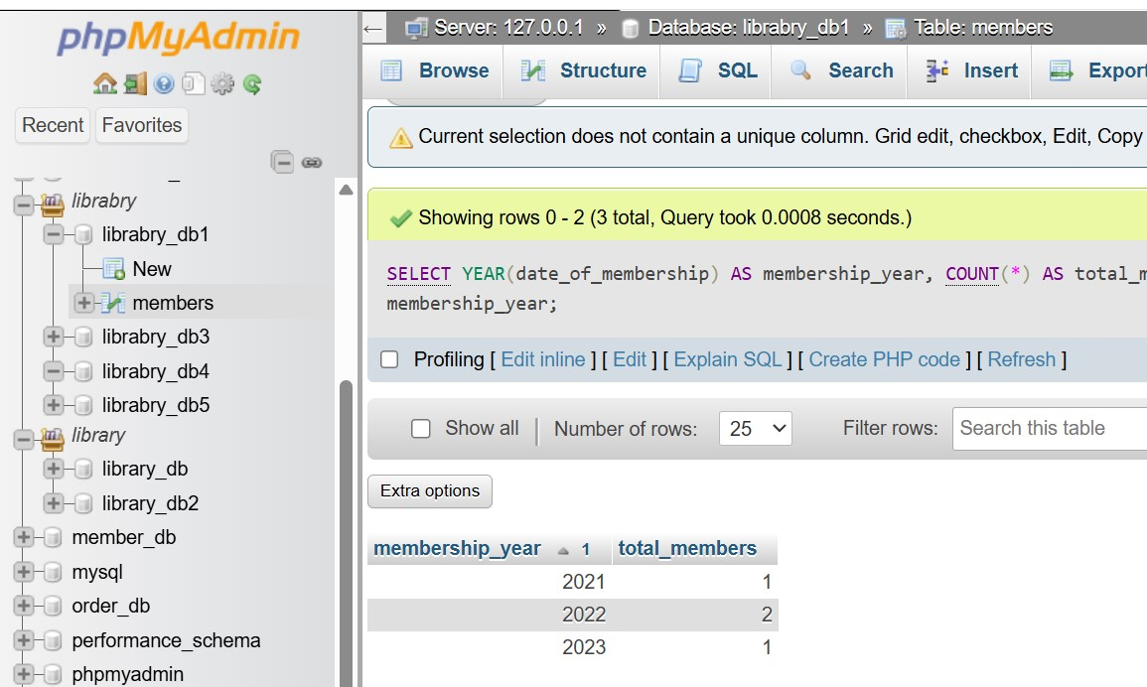

16. SQL Stored Procedure

LAB EXERCISES:

Lab 3: Write a stored procedure to retrieve all books by a particular author.

Ans.

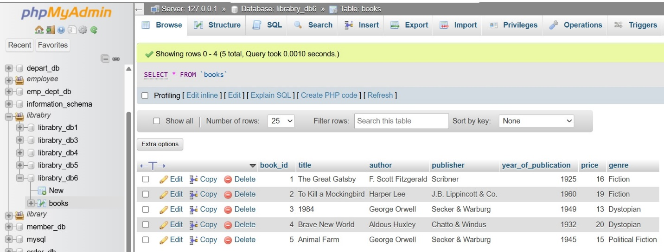

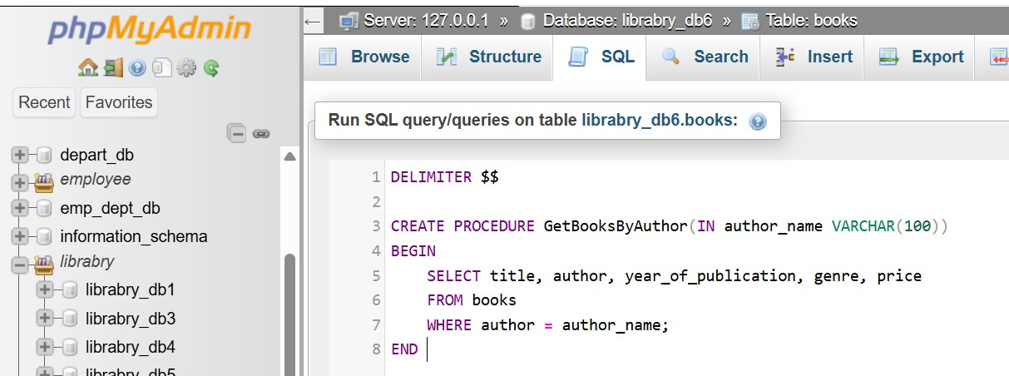

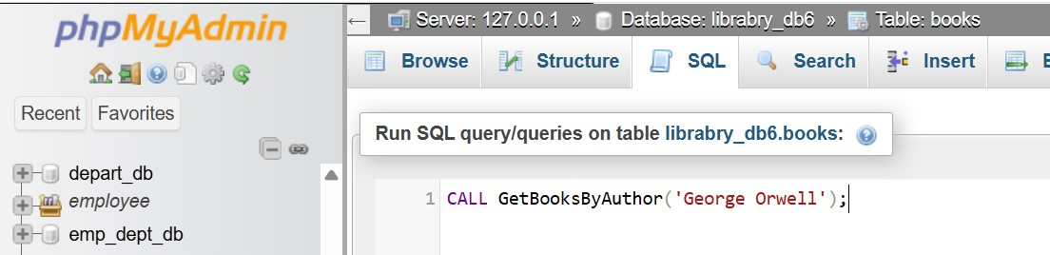

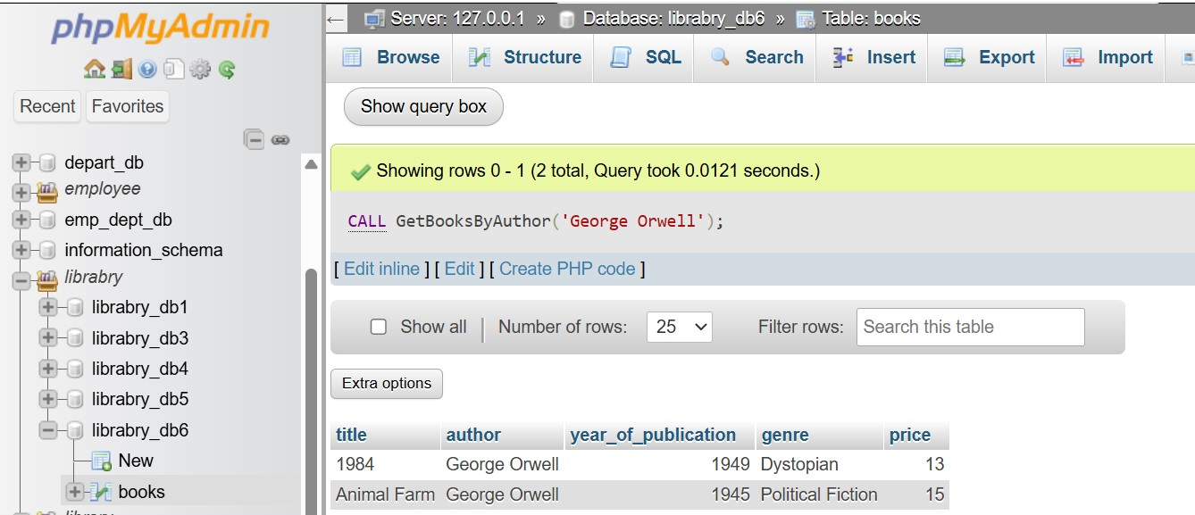

Lab 4: Write a stored procedure that takes book_id as an argument and returns the price of the book.

Ans.



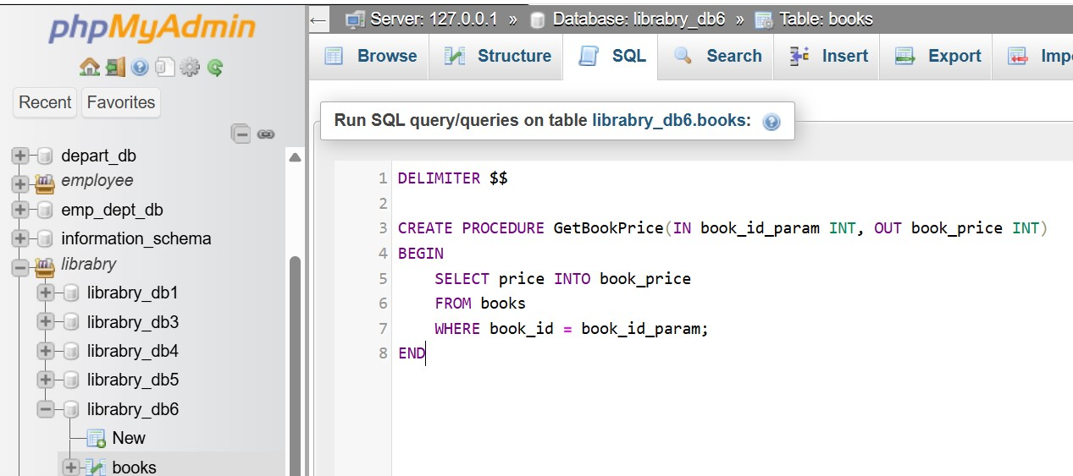

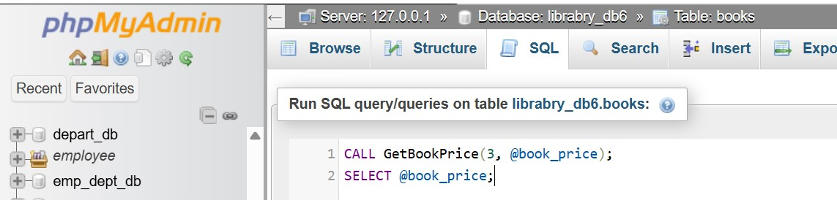

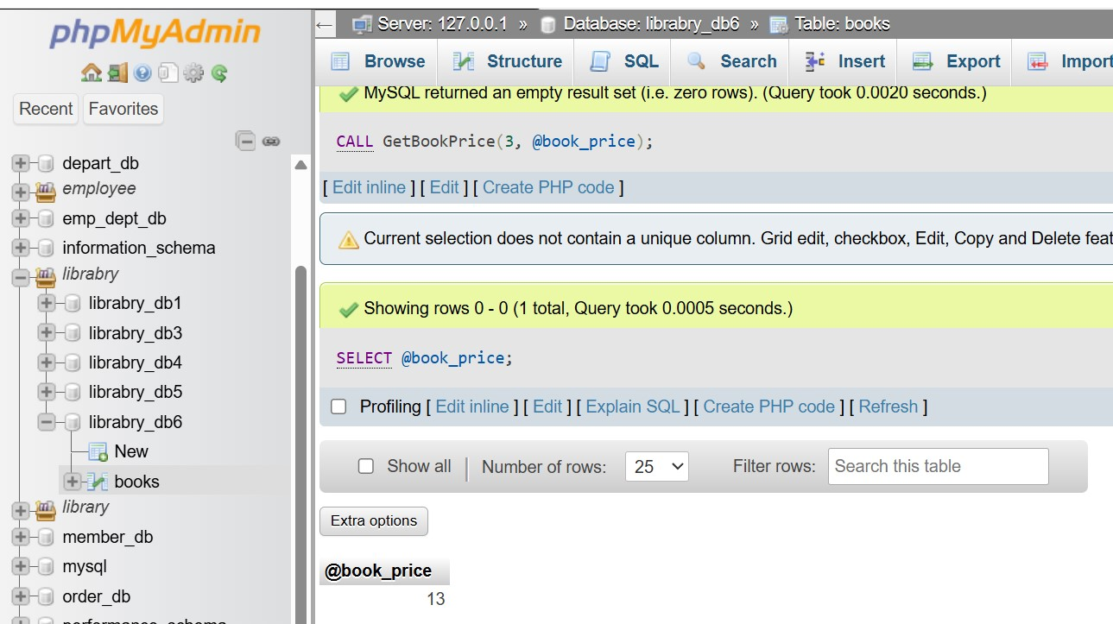

17. SQL View

LAB EXERCISES:

Lab 3: Create a view to show only the title, author, and price of books from the books table.

Ans.



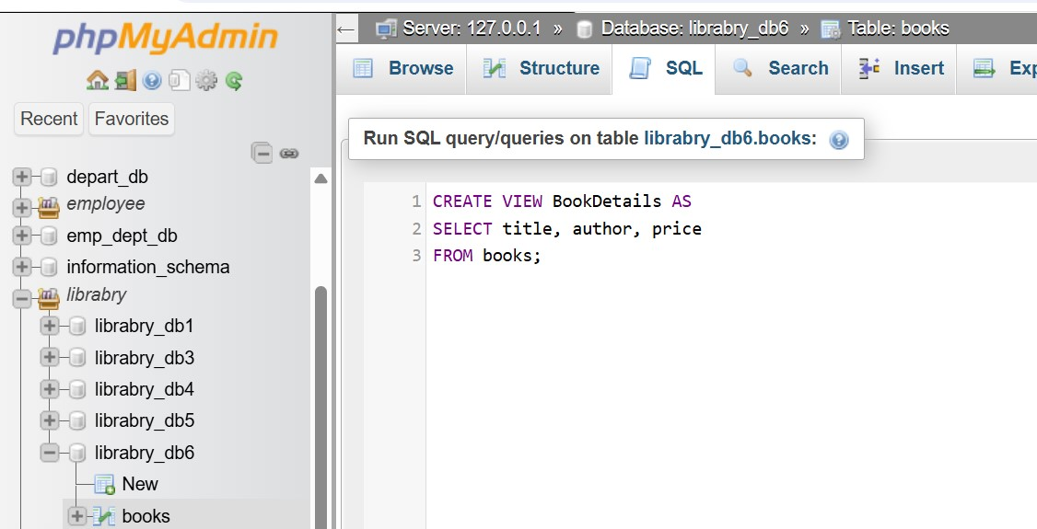

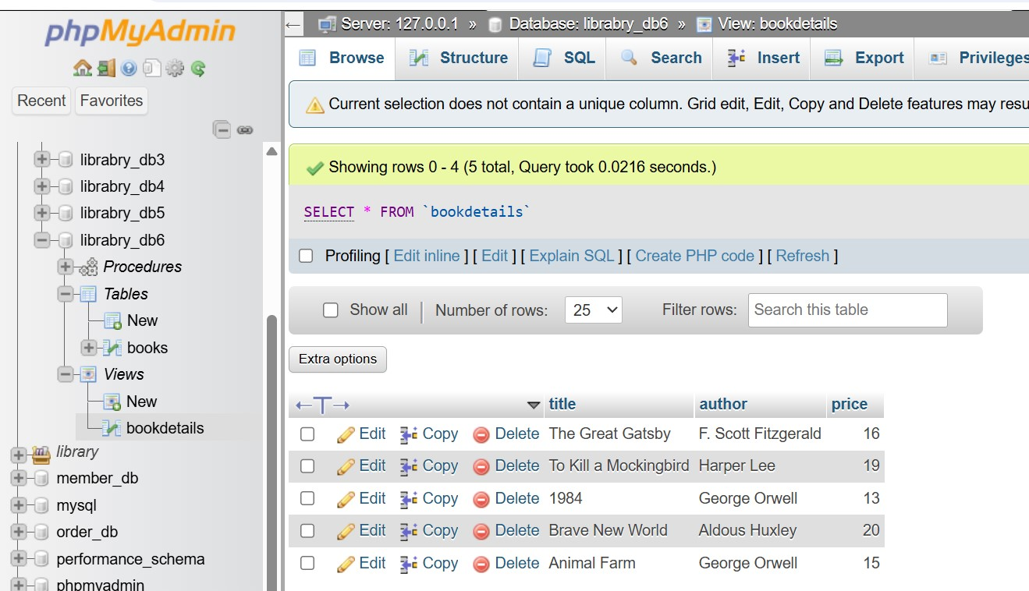

Lab 4: Create a view to display members who joined before 2020.

Ans.

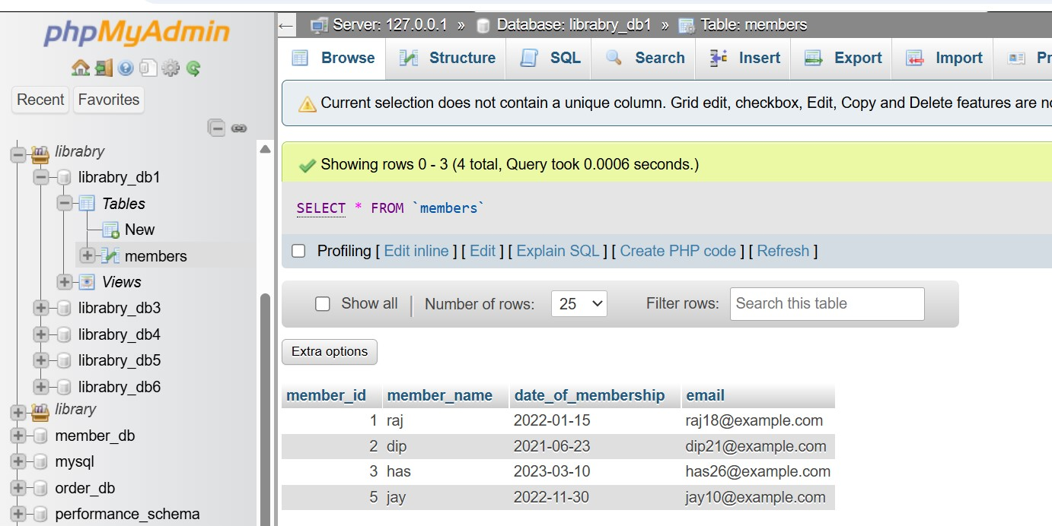

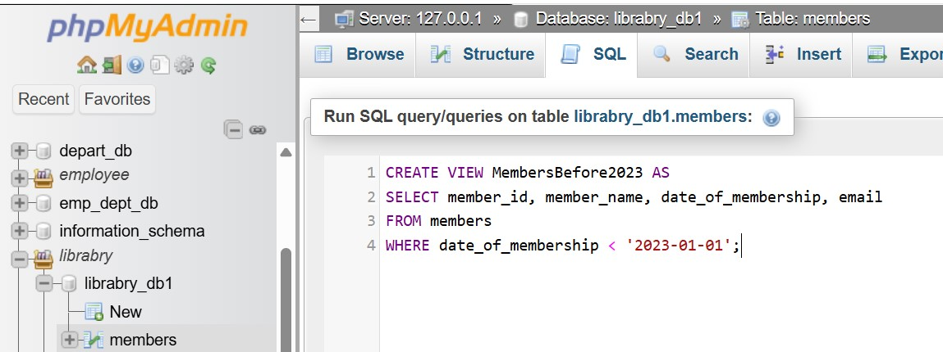

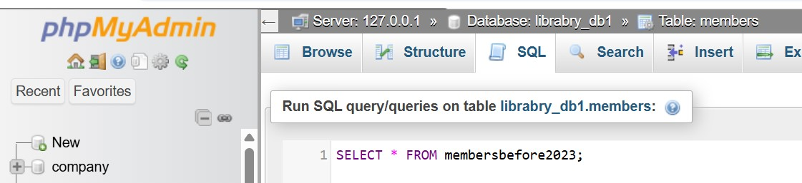

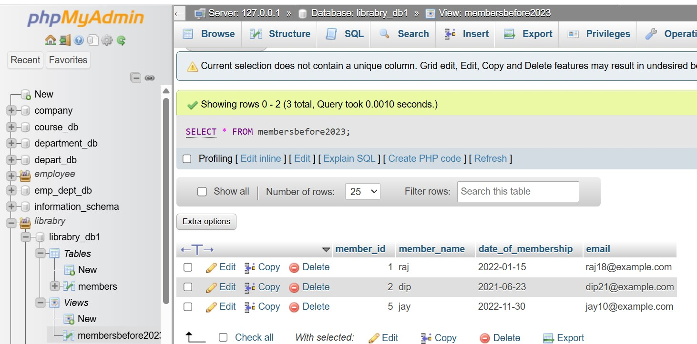

18. SQL Trigger

LAB EXERCISES:

Lab 3: Create a trigger to automatically update the last_modified timestamp of the books table whenever a record is updated.

Ans.

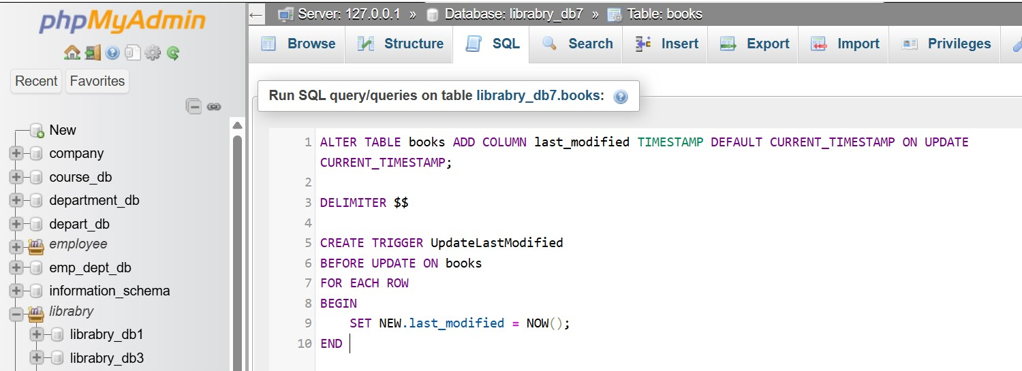

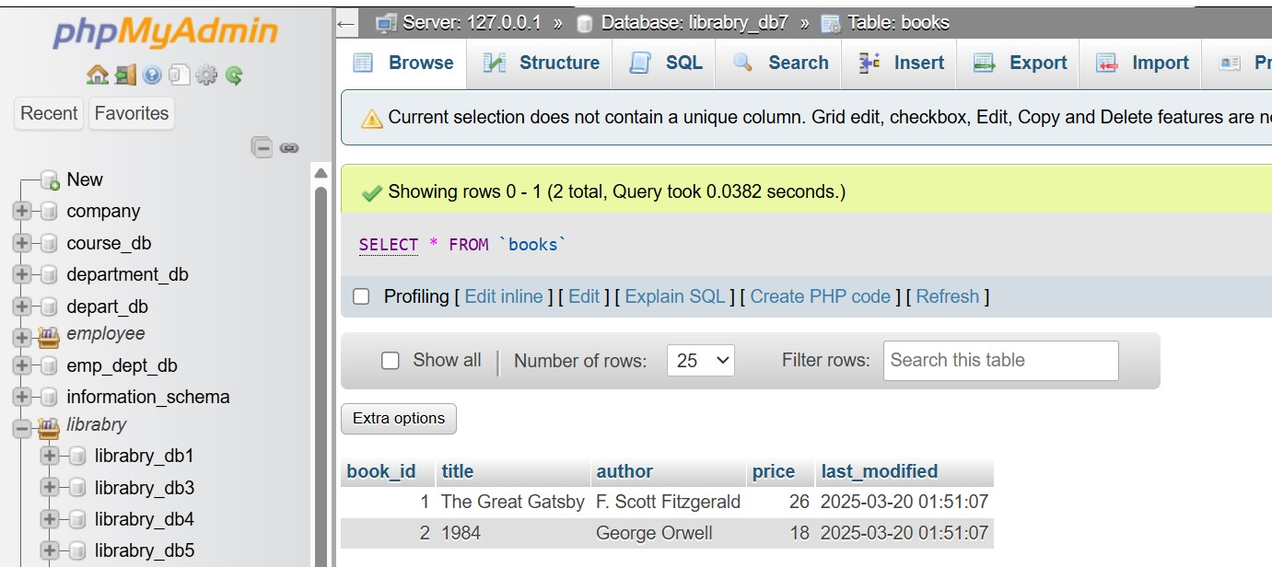

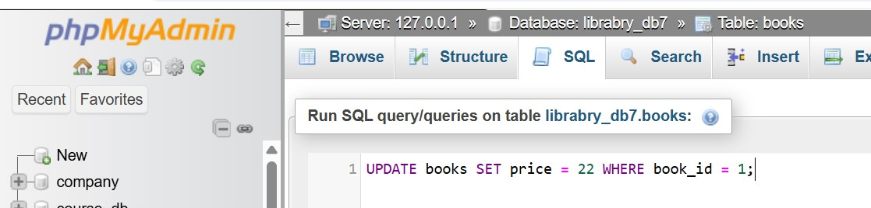

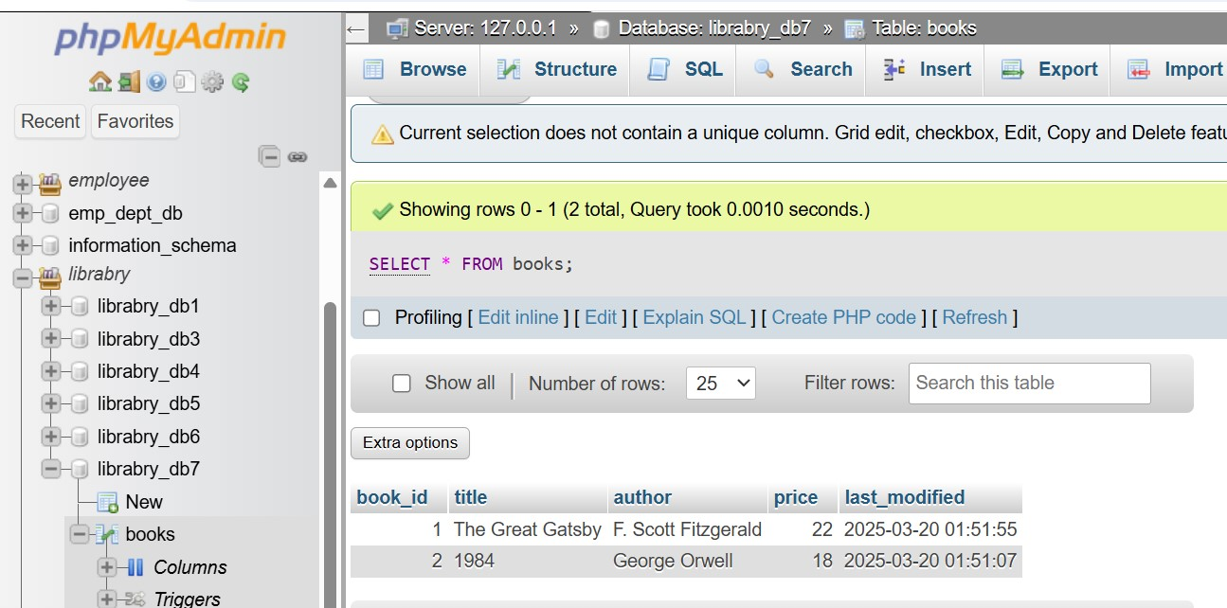

Lab 4: Create a trigger that inserts a log entry into a log_changes table whenever a DELETE operation is performed on the books table.

Ans.

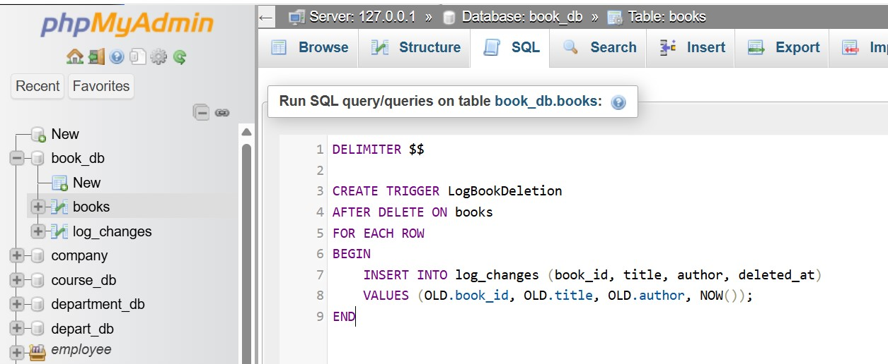

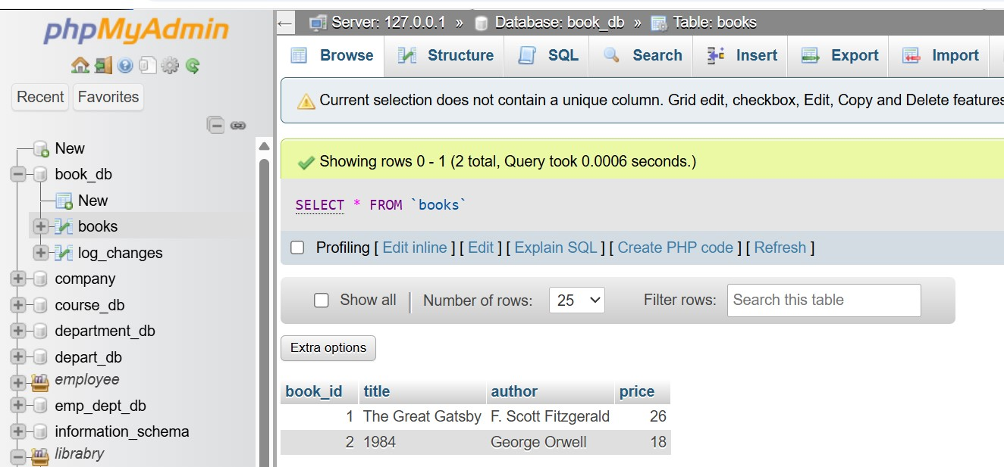

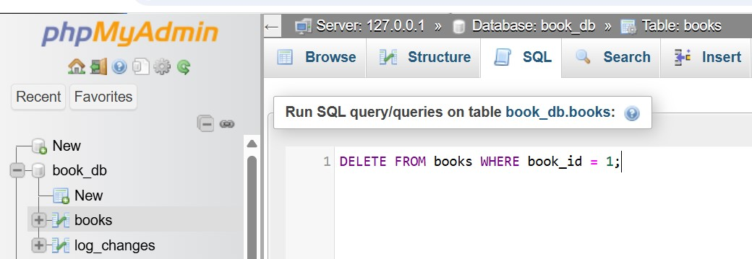

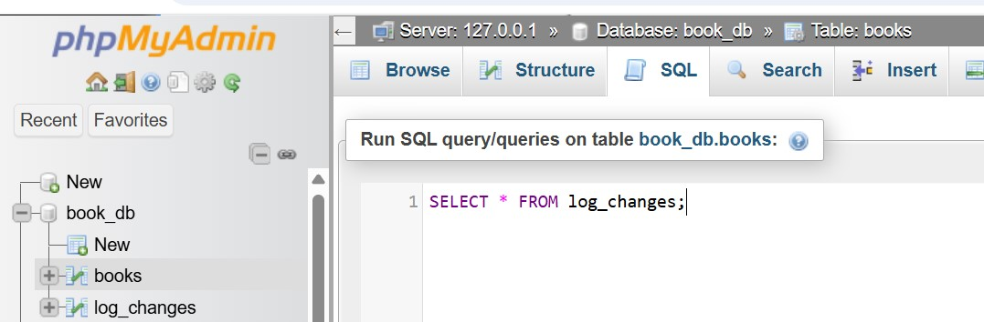

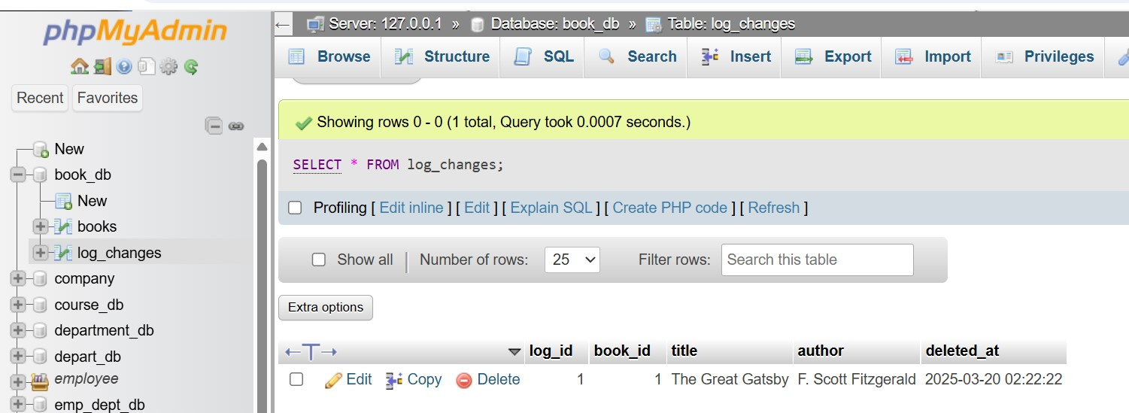

19. Introduction to PL/SQL

LAB EXERCISES:

Lab 3: Write a PL/SQL block to insert a new book into the books table and display a confirmation message.

Ans.

DECLARE

v_book_id books.book_id%TYPE := 101; -- Example book_id

v_title books.title%TYPE := 'To Kill a Mockingbird';

v_author books.author%TYPE := 'Harper Lee';

v_publisher books.publisher%TYPE := 'J.B. Lippincott & Co.';

v_year books.year_of_publication%TYPE := 1960;

v_price books.price%TYPE := 18.99;

BEGIN

INSERT INTO books (book_id, title, author, publisher, year_of_publication, price)

VALUES (v_book_id, v_title, v_author, v_publisher, v_year, v_price);

DBMS_OUTPUT.PUT_LINE('Book "' || v_title || '" has been successfully added!');

COMMIT;

EXCEPTION

WHEN OTHERS THEN

DBMS_OUTPUT.PUT_LINE('Error: ' || SQLERRM);

ROLLBACK; -- Rollback transaction in case of an error

END;

/

Lab 4: Write a PL/SQL block to display the total number of books in the books table.

Ans.

SET SERVEROUTPUT ON;

DECLARE

v_total_books NUMBER; -- Variable to store total book count

BEGIN

SELECT COUNT(*) INTO v_total_books FROM books;

DBMS_OUTPUT.PUT_LINE('Total number of books in the library: ' || v_total_books);

EXCEPTION

WHEN OTHERS THEN

DBMS_OUTPUT.PUT_LINE('Error: ' || SQLERRM);

END;

/

20. PL/SQL Syntax

LAB EXERCISES:

Lab 3: Write a PL/SQL block to declare variables for book_id and price, assign values, and display the results.

Ans.

SET SERVEROUTPUT ON;

DECLARE

v_book_id books.book_id%TYPE := 101; -- Assigning a book ID

v_price books.price%TYPE := 25.99; -- Assigning a price

BEGIN

DBMS_OUTPUT.PUT_LINE('Book ID: ' || v_book_id);

DBMS_OUTPUT.PUT_LINE('Price: $' || v_price);

END;

/

Lab 4: Write a PL/SQL block using constants and perform arithmetic operations on book prices.

Ans.

SET SERVEROUTPUT ON;

DECLARE

c_discount CONSTANT NUMBER := 0.10;

c_tax CONSTANT NUMBER := 0.05;

v_book_id books.book_id%TYPE := 101

v_price books.price%TYPE;

v_discounted_price NUMBER;

v_final_price NUMBER;

BEGIN

SELECT price INTO v_price FROM books WHERE book_id = v_book_id;

v_discounted_price := v_price - (v_price * c_discount);

v_final_price := v_discounted_price + (v_discounted_price * c_tax);

DBMS_OUTPUT.PUT_LINE('Original Price: $' || TO_CHAR(v_price, '9999.99'));

DBMS_OUTPUT.PUT_LINE('Discounted Price (10% off): $' || TO_CHAR(v_discounted_price, '9999.99'));

DBMS_OUTPUT.PUT_LINE('Final Price after 5% Tax: $' || TO_CHAR(v_final_price, '9999.99'));

EXCEPTION

WHEN NO_DATA_FOUND THEN

DBMS_OUTPUT.PUT_LINE('Error: No book found with the given ID.');

WHEN OTHERS THEN

DBMS_OUTPUT.PUT_LINE('Error: ' || SQLERRM);

END;

/

21. PL/SQL Control Structures

LAB EXERCISES:

Lab 3: Write a PL/SQL block using IF-THEN-ELSE to check if a book's price is above $100 and print a message accordingly.

Ans.

SET SERVEROUTPUT ON;

DECLARE

v_book_id books.book_id%TYPE := 101;

v_price books.price%TYPE;

BEGIN

SELECT price INTO v_price FROM books WHERE book_id = v_book_id;

IF v_price > 100 THEN

DBMS_OUTPUT.PUT_LINE('The book is expensive. Price: $' || TO_CHAR(v_price, '9999.99'));

ELSE

DBMS_OUTPUT.PUT_LINE('The book is affordable. Price: $' || TO_CHAR(v_price, '9999.99'));

END IF;

EXCEPTION

WHEN NO_DATA_FOUND THEN

DBMS_OUTPUT.PUT_LINE('Error: No book found with the given ID.');

WHEN OTHERS THEN

DBMS_OUTPUT.PUT_LINE('Error: ' || SQLERRM);

END;

/

Lab 4: Use a FOR LOOP in PL/SQL to display the details of all books one by one.

Ans.

SET SERVEROUTPUT ON;

DECLARE

CURSOR book_cursor IS

SELECT book_id, title, author, price FROM books;

v_book books%ROWTYPE;

BEGIN

FOR v_book IN book_cursor LOOP

DBMS_OUTPUT.PUT_LINE('Book ID: ' || v_book.book_id);

DBMS_OUTPUT.PUT_LINE('Title: ' || v_book.title);

DBMS_OUTPUT.PUT_LINE('Author: ' || v_book.author);

DBMS_OUTPUT.PUT_LINE('Price: $' || TO_CHAR(v_book.price, '9999.99'));

DBMS_OUTPUT.PUT_LINE('------------------------------');

END LOOP;

END;

/

22. SQL Cursors

LAB EXERCISES:

Lab 3: Write a PL/SQL block using an explicit cursor to fetch and display all records from the members table.

Ans.

SET SERVEROUTPUT ON;

DECLARE

CURSOR member_cursor IS

SELECT member_id, member_name, date_of_membership, email FROM members;

v_member member_cursor%ROWTYPE;

BEGIN

OPEN member_cursor;

LOOP

FETCH member_cursor INTO v_member;

EXIT WHEN member_cursor%NOTFOUND;

DBMS_OUTPUT.PUT_LINE('Member ID: ' || v_member.member_id);

DBMS_OUTPUT.PUT_LINE('Name: ' || v_member.member_name);

DBMS_OUTPUT.PUT_LINE('Joined: ' || TO_CHAR(v_member.date_of_membership, 'YYYY-MM-DD'));

DBMS_OUTPUT.PUT_LINE('Email: ' || v_member.email);

DBMS_OUTPUT.PUT_LINE('------------------------------');

END LOOP;

CLOSE member_cursor;

END;

/

Lab 4: Create a cursor to retrieve books by a particular author and display their titles.

Ans.

DELIMITER $$

CREATE PROCEDURE GetBooksByAuthor(IN author_name VARCHAR(255))

BEGIN

DECLARE done INT DEFAULT 0;

DECLARE book_title VARCHAR(255);

DECLARE book_cursor CURSOR FOR

SELECT title FROM books WHERE author = author_name;

DECLARE CONTINUE HANDLER FOR NOT FOUND SET done = 1;

OPEN book_cursor;

read_loop: LOOP

FETCH book_cursor INTO book_title;

IF done THEN

LEAVE read_loop;

END IF;

SELECT book_title;

END LOOP;

CLOSE book_cursor;

END $$

23. Rollback and Commit Savepoint

LAB EXERCISES:

Lab 3: Perform a transaction that includes inserting a new member, setting a SAVEPOINT, and rolling back to the savepoint after making updates.

Ans.

START TRANSACTION;

INSERT INTO members (name, email) VALUES ('John Doe', 'johndoe@example.com');

SAVEPOINT before_update;

UPDATE members SET email = 'newemail@example.com' WHERE name = 'John Doe';

ROLLBACK TO SAVEPOINT before_update;

COMMIT;

Lab 4: Use COMMIT after successfully inserting multiple books into the books table, then use ROLLBACK to undo a set of changes made after a savepoint.

Ans.

START TRANSACTION;

INSERT INTO books (title, author) VALUES

('The Catcher in the Rye', 'J.D. Salinger'),

('Brave New World', 'Aldous Huxley'),

('Moby-Dick', 'Herman Melville');

COMMIT;

START TRANSACTION;

SAVEPOINT before_update;

UPDATE books SET author = 'Unknown Author' WHERE title = 'Moby-Dick';

DELETE FROM books WHERE title = 'Brave New World';

ROLLBACK TO SAVEPOINT before_update;

COMMIT;